**Computer Organization and Assembly Language**

**Semester Project Documentation**

**Submitted to:**

**Mr. Naeem Raza**

**Submitted by:**

**Khadija Maham**

**Roll #:**

**068**

**BS CS 5th Semester**

**Department of Computer Science**



**National University of Modern Languages**

**Faisalabad Campus**

**Introduction:**

Salon Management System implemented in Assembly Language, designed to streamline and enhance the salon experience for both customers and salon staff. This project aims to provide an efficient solution for managing salon services, generating bills, applying discounts based on specific criteria, and collecting customer feedback.

**Features:**

**Services Menu Display:**

The system presents a user-friendly menu showcasing various salon services, including haircuts, styling, coloring, and other beauty treatments.

Users can easily navigate through the menu to select their desired services.

**Bill Generation:**

Once customers have made their service selections, the system calculates the total bill amount.

The bill includes detailed information about each selected service and their respective prices.

**Discount Application:**

The system intelligently applies discounts based on predefined criteria, such as:

* Bill exceeds 10 thousand.
* Has the coupon code.
* 4 thousand rupees Discount is given.

**Customer Feedback:**

After the transaction is complete, the system prompts customers to provide feedback on their salon experience.

Feedback can include ratings for services, suggestions for improvement, and comments on overall satisfaction.

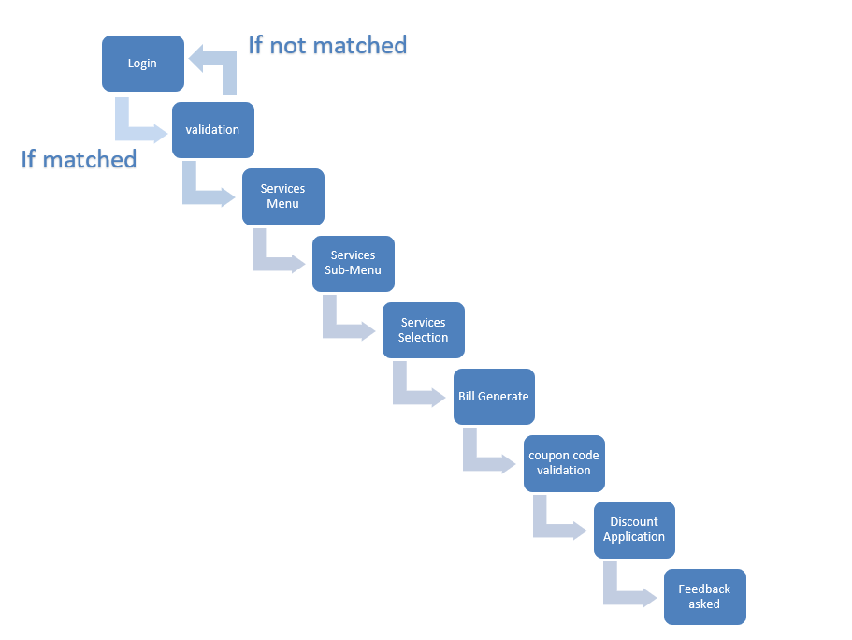**Flowchart:**

**Code:**

include irvine32.inc

.data

;-----------------------------------------------------------------------------------------------------------------------------------------------------------------------------

; <<<<<<<<<<<<<<<<< Login Page Data >>>>>>>>>>>>>>>>>>>

;-----------------------------------------------------------------------------------------------------------------------------------------------------------------------------

logo1 byte " /\ /\ /\ /\ ",0

logo2 byte " / \ / \ / \ / \ ",0

logo3 byte " / \ | | | | / \ ",0

logo4 byte " / \ \ / \ / / \ ",0

logo5 byte " / \ | | | | / \ ",0

logo6 byte " / \ | | | | / \ ",0

logo7 byte " /____________\ | | | | /____________\ ",0

logo8 byte " \ / | | | | \ / ",0

logo9 byte " \ ___ / | | | | \ ___ / ",0

logo10 byte " \ |___| /____________|_|___________|_|_______________\ |___| / ",0

logo11 byte " \ |___| / \ |___| / ",0

logo12 byte " \ / Welcome to \ / ",0

logo13 byte " \ / Royal Salon \ / ",0

logo14 byte " \ / \ / ",0

logo15 byte " \ / Login to get \ / ",0

logo16 byte " \ / The Princess treatment \ / ",0

logo17 byte " \__________/____________________________________________\__________/ ",0

logo18 byte "Enter Password to get started:",0

logintext byte "Enter Password to get started:",0

; login succussfull message

chain byte " <><><><><><><><<><><><><><><><><><><><>",0

successmsg byte " <><> Login successful! <><>",0

; login failed message

failedmsg byte " <><><><><> Password is incorrect! Try again <><><><><>",0

;-----------------------------------------------------------------------------------------------------------------------------------------------------------------------------

; <<<<<<<<<<<<<<<<< Services Data >>>>>>>>>>>>>>>>>>>

;-----------------------------------------------------------------------------------------------------------------------------------------------------------------------------

v1 byte "<><><><><><><><><><><><><><><><><><><><><><><><><><><><><><><><><><><><><><><><><><><><><><><><><><><><><><><><><><><><>",0

v2 byte "<><> SERVICES MENU <><>",0

v3 byte " Choose from available services given below:",0

v4 byte " || Enter 0 ~ to log out ||",0

v5 byte " || Enter 1 ~ Haircut ||",0

v6 byte " || Enter 2 ~ Hair color ||",0

v7 byte " || Enter 3 ~ Hair Straighting treatment ||",0

v8 byte " || Enter 4 ~ Hair care treatment ||",0

v9 byte " || Enter 5 ~ Hair styling ||",0

v10 byte " || Enter 6 ~ Makeup ||",0

v11 byte " || Enter 7 ~ Bridal Packages ||",0

v12 byte " || Enter 8 ~ Nails ||",0

v13 byte " || Enter 9 ~ Pedicure & Manicure ||",0

v14 byte " || Enter 10 ~ Eyebrows & Lashes ||",0

v15 byte " || Enter 11 ~ Skin care ||",0

v16 byte " ------------------------------------------------------------------- ",0

hcheading byte "<><> HAIRCUT <><>",0

hcheading2 byte " | TYPE: PRICE: |",0

hcspace byte " | |",0

hcopt1 byte " | Enter 0 ~ Long mid 5,000 |",0

hc1v dd 5000

hcopt2 byte " | Enter 1 ~ Short bob 8,000 |",0

hc2v dd 8000

hcopt3 byte " | Enter 2 ~ Layers 6,000 |",0

hc3v dd 6000

hcopt4 byte " | Enter 3 ~ Step cut 10,000 |",0

hc4v dd 10000

hcolorheading byte "<><> HAIR COLOR <><>",0

hcolorheading2 byte " | TYPE: PRICE: |",0

hcolorspace byte " | |",0

hcoloropt1 byte " | Enter 0 ~ French Balayage 5,000 |",0

hcolor1v dd 5000

hcoloropt2 byte " | Enter 1 ~ Corrective Color 2,000 |",0

hcolor2v dd 2000

hcoloropt3 byte " | Enter 2 ~ Highlights 6,000 |",0

hcolor3v dd 6000

hcoloropt4 byte " | Enter 3 ~ Roots Coverage 5,000 |",0

hcolor4v dd 5000

hcoloropt5 byte " | Enter 4 ~ Cut Down 9,000 |",0

hcolor5v dd 9000

hsheading byte "<><> HAIR STRAIGHTING <><>",0

hsheading2 byte " | TYPE: PRICE: |",0

hsspace byte " | |",0

hsopt1 byte " | Enter 0 ~ Frizz free 3,000 |",0

hs1v dd 3000

hsopt2 byte " | Enter 1 ~ Permanent 15,000 |",0

hs2v dd 15000

hsopt3 byte " | Enter 2 ~ Half Head 8,000 |",0

hs3v dd 8000

hsopt4 byte " | Enter 3 ~ Additional 1,000 |",0

hs4v dd 1000

htheading byte "<><> HAIR TREATMENT <><>",0

htheading2 byte " | TYPE: PRICE: |",0

htspace byte " | |",0

htopt1 byte " | Enter 0 ~ Shine enhancing 7,000 |",0

ht1v dd 7000

htopt2 byte " | Enter 1 ~ Nourishing 7,000 |",0

ht2v dd 7000

htopt3 byte " | Enter 2 ~ Hair Repair 16,000 |",0

ht3v dd 16000

htopt4 byte " | Enter 3 ~ Volumizing 11,000 |",0

ht4v dd 11000

htopt5 byte " | Enter 4 ~ Anti Dandruff 20,000 |",0

ht5v dd 20000

htopt6 byte " | Enter 5 ~ Fortifying Plex 25,000 |",0

ht6v dd 25000

hstylingheading byte "<><> HAIR STYLING <><>",0

hstylingheading2 byte " | TYPE: PRICE: |",0

hstylingspace byte " | |",0

hstylingopt1 byte " | Enter 0 ~ Updos 10,000 |",0

hstyle1v dd 10000

hstylingopt2 byte " | Enter 1 ~ Temporary Texturising 15,000 |",0

hstyle2v dd 15000

hstylingopt3 byte " | Enter 2 ~ Hair extension 20,000 |",0

hstyle3v dd 20000

hstylingopt4 byte " | Enter 3 ~ Blow dry 18,000 |",0

hstyle4v dd 18000

hstylingopt5 byte " | Enter 4 ~ Kerastase 13,000 |",0

hstyle5v dd 13000

hstylingopt6 byte " | Enter 5 ~ Curling 11,000 |",0

hstyle6v dd 11000

makeupheading byte "<><> MAKEUP <><>",0

makeupheading2 byte " | TYPE: PRICE: |",0

makeupspace byte " | |",0

makeupopt1 byte " | Enter 0 ~ Signature makeup 75,000 |",0

makeup1v dd 75000

makeupopt2 byte " | Enter 1 ~ Bridal makeup 30,000 |",0

makeup2v dd 30000

makeupopt3 byte " | Enter 2 ~ Evening makeup 15,000 |",0

makeup3v dd 15000

makeupopt4 byte " | Enter 3 ~ Minimal makeup 12,000 |",0

makeup4v dd 12000

bpheading byte "<><> BRIDAL PACKAGES <><>",0

bpheading2 byte " | TYPE: PRICE: |",0

bpspace byte " | |",0

bpopt1 byte " | Enter 0 ~ Luxury Package 24,200 |",0

bp1v dd 24200

bpopt2 byte " | Enter 1 ~ Classic Package 19,800 |",0

bp2v dd 19800

nailheading byte "<><> NAILS <><>",0

nailheading2 byte " | TYPE: PRICE: |",0

nailspace byte " | |",0

nailopt1 byte " | Enter 0 ~ Acrylics 7000 |",0

nail1v dd 7000

nailopt2 byte " | Enter 1 ~ Refills 4000 |",0

nail2v dd 4000

nailopt3 byte " | Enter 2 ~ Nail Repair 1000 |",0

nail3v dd 1000

nailopt4 byte " | Enter 3 ~ Nail Art 4000 |",0

nail4v dd 4000

nailopt5 byte " | Enter 4 ~ Gellish Polish 3000 |",0

nail5v dd 3000

nailopt6 byte " | Enter 5 ~ Shape, buff & polish 2000 |",0

nail6v dd 2000

pmheading byte "<><> PEDICUDE & MANICURE <><>",0

pmheading2 byte " | TYPE: PRICE: |",0

pmspace byte " | |",0

pmopt1 byte " | Enter 0 ~ luxury gold mask 4,000 |",0

pm1v dd 4000

pmopt2 byte " | Enter 1 ~ Hydrating paraffin treatment 4,000 |",0

pm2v dd 4000

pmopt3 byte " | Enter 2 ~ Express 3,000 |",0

pm3v dd 3000

pmopt4 byte " | Enter 3 ~ Therapeutic 3,500 |",0

pm4v dd 3500

elheading byte "<><> EYEBROWS & LASHES <><>",0

elheading2 byte " | TYPE: PRICE: |",0

elspace byte " | |",0

elopt1 byte " | Enter 0 ~ Classic lash extension 20,000 |",0

el1v dd 20000

elopt2 byte " | Enter 1 ~ Dimensional lash extension 20,000 |",0

el2v dd 20000

elopt3 byte " | Enter 2 ~ Brow tint 10,000 |",0

el3v dd 10000

elopt4 byte " | Enter 3 ~ Eyelash tint 8,000 |",0

el4v dd 8000

elopt5 byte " | Enter 4 ~ Eyebrow lamination 8,000 |",0

el5v dd 8000

elopt6 byte " | Enter 5 ~ Eyebrow reshaping 2,000 |",0

el6v dd 2000

scheading byte "<><> SKIN CARE <><>",0

scheading2 byte " | TYPE: PRICE: |",0

scspace byte " | |",0

scopt1 byte " | Enter 0 ~ Premium package 11,000 |",0

sc1v dd 11000

scopt2 byte " | Enter 1 ~ Deluxe package 9,000 |",0

sc2v dd 9000

scopt3 byte " | Enter 2 ~ Classic package 7,000 |",0

sc3v dd 7000

scopt4 byte " | Enter 3 ~ Face polish 3,000 |",0

sc4v dd 3000

scopt5 byte " | Enter 4 ~ Facial Hair removal 2,000 |",0

sc5v dd 2000

scopt6 byte " | Enter 5 ~ Herbal polish 10,000 |",0

sc6v dd 10000

scopt7 byte " | Enter 6 ~ Wax 7,000 |",0

sc7v dd 7000

;-----------------------------------------------------------------------------------------------------------------------------------------------------------------------------

; <<<<<<<<<<<<<<<<< Products >>>>>>>>>>>>>>>>>>>

;-----------------------------------------------------------------------------------------------------------------------------------------------------------------------------

product1 dd 0

product2 dd 0

product3 dd 0

;-----------------------------------------------------------------------------------------------------------------------------------------------------------------------------

; <<<<<<<<<<<<<<<<< Cart >>>>>>>>>>>>>>>>>>>

;-----------------------------------------------------------------------------------------------------------------------------------------------------------------------------

cart1 byte " <<<<<<<<<<<<<<<<<<<<<<<<<< Service is added to the cart! >>>>>>>>>>>>>>>>>>>>>>>>>>>> ",0

cart2 byte " You can have two more service if you want. ",0

cart3 byte " Enter 1 to select more or Enter 0 to generate Bill. ",0

cart4 byte " You can have one more service if you want. ",0

; cart4 will come with product2

;-----------------------------------------------------------------------------------------------------------------------------------------------------------------------------

; <<<<<<<<<<<<<<<<< bill array >>>>>>>>>>>>>>>>>>>

;-----------------------------------------------------------------------------------------------------------------------------------------------------------------------------

productarray DWORD 3 DUP(?) ; declaring array for storing product prices

;-----------------------------------------------------------------------------------------------------------------------------------------------------------------------------

; <<<<<<<<<<<<<<<<< bill screen >>>>>>>>>>>>>>>>>>>

;-----------------------------------------------------------------------------------------------------------------------------------------------------------------------------

bill1 byte " <<<<<<<<<<<<<<<<<<<<<<<<<<<<<<<<<<<<>>>>>>>>>>>>>>>>>>>>>>>>>>>>>>>>>>>>>>>>>>>>>> ",0

bill2 byte " < > ",0

bill3 byte " < Bill > ",0

bill4 byte " < Total amount: ",0

bill5 byte " > ",0

bill6 byte " Enter the coupon code for the discount:",0

;-----------------------------------------------------------------------------------------------------------------------------------------------------------------------------

; <<<<<<<<<<<<<<<<< bill Cash amounts >>>>>>>>>>>>>>>>>>>

;-----------------------------------------------------------------------------------------------------------------------------------------------------------------------------

withoutdiscountamount dd 0 ; with out discount amount

withdiscountamount dd 0 ; with discount amount

billamount dd 0 ; without applying discount

lessthantenthousand byte " Sorry, Discount applies to bills over ten thousand. Your bill is below the threshold.",0

greaterthantenthousand byte " Your bill with discount is ",0

wrongcouponcode byte " Unfortunately the code was wrong! We can't give you another chance, sorry!",0

wrongcouponcode2 byte " You have to pay the whole amount.",0

;-----------------------------------------------------------------------------------------------------------------------------------------------------------------------------

; <<<<<<<<<<<<<<<<< Invalid Value >>>>>>>>>>>>>>>>>>>

;-----------------------------------------------------------------------------------------------------------------------------------------------------------------------------

invalidopt byte "Choose under the given options!",0

chooseagain byte "Enter to Select the value again: ",0

;-----------------------------------------------------------------------------------------------------------------------------------------------------------------------------

; <<<<<<<<<<<<<<<<< File Handling >>>>>>>>>>>>>>>>>>>

;-----------------------------------------------------------------------------------------------------------------------------------------------------------------------------

menuPrompt BYTE " Press 1 to give feedback, Press 2 to leave.", 0

userInputBuffer BYTE 50 DUP (?)

; For Writing to File

enterNamePrompt BYTE " Enter Feedback: ", 0

userNameInput BYTE 50 DUP (?)

nameSavedMessage BYTE " Thank you for visiting and sharing your feedback!", 0

outputFile BYTE "feedback.txt", 0

outputFile2 BYTE "thankyou.txt", 0

; For Reading from File

readFromFileBuffer BYTE 50 DUP (?)

fileHandle DWORD ?

;-----------------------------------------------------------------------------------------------------------------------------------------------------------------------------

;-----------------------------------------------------------------------------------------------------------------------------------------------------------------------------

;-----------------------------------------------------------------------------------------------------------------------------------------------------------------------------

;-----------------------------------------------------------------------------------------------------------------------------------------------------------------------------

;-----------------------------------------------------------------------------------------------------------------------------------------------------------------------------

;-----------------------------------------------------------------------------------------------------------------------------------------------------------------------------

;-----------------------------------------------------------------------------------------------------------------------------------------------------------------------------

; <<<<<<<<<<<<<<<<< Code Part >>>>>>>>>>>>>>>>>>>

;-----------------------------------------------------------------------------------------------------------------------------------------------------------------------------

;-----------------------------------------------------------------------------------------------------------------------------------------------------------------------------

;-----------------------------------------------------------------------------------------------------------------------------------------------------------------------------

;-----------------------------------------------------------------------------------------------------------------------------------------------------------------------------

;-----------------------------------------------------------------------------------------------------------------------------------------------------------------------------

;-----------------------------------------------------------------------------------------------------------------------------------------------------------------------------

;-----------------------------------------------------------------------------------------------------------------------------------------------------------------------------

; <<<<<<<<<<<<<<<<< Main Procedure >>>>>>>>>>>>>>>>>>>

.code ; code start

main proc

mov eax, lightmagenta

call settextcolor

call loginpage ; calling loginpage

exit

main endp

;------------------------------------------------------------------------------------------------------------------------------------------------------------------------------

; <<<<<<<<<<<<<<<<< Login Page >>>>>>>>>>>>>>>>>>>

loginpage proc

call crlf

call crlf

call crlf

mov edx, offset logo1

call writestring

call crlf

mov edx, offset logo2

call writestring

call crlf

mov edx, offset logo3

call writestring

call crlf

mov edx, offset logo4

call writestring

call crlf

mov edx, offset logo5

call writestring

call crlf

mov edx, offset logo6

call writestring

call crlf

mov edx, offset logo7

call writestring

call crlf

mov edx, offset logo8

call writestring

call crlf

mov edx, offset logo9

call writestring

call crlf

mov edx, offset logo10

call writestring

call crlf

mov edx, offset logo11

call writestring

call crlf

mov edx, offset logo12

call writestring

call crlf

mov edx, offset logo13

call writestring

call crlf

mov edx, offset logo14

call writestring

call crlf

mov edx, offset logo15

call writestring

call crlf

mov edx, offset logo16

call writestring

call crlf

mov edx, offset logo17

call writestring

call crlf

call crlf

call crlf

call crlf

login:

mov eax,9

call writechar

call writechar

call writechar

call writechar

call writechar

mov edx, offset logintext

call writestring

;<<<<<<<<<<<<<<<<<<<<<<<<< Encryption for login >>>>>>>>>>>>>>>>>>>>>>>>>>>>>>>>>>>>>>>>>>>>>

mov eax, 999

xor eax,2

mov ebx,eax

call readint

xor eax,2

call crlf

CMP eax, ebx

JE loginsuccessful

JNE tryagain

exit

loginsuccessful:

mov edx, offset chain

call writestring

call crlf

mov edx, offset successmsg

call writestring

call crlf

mov edx, offset chain

call writestring

call crlf

call crlf

call waitmsg

call home

exit

tryagain:

mov edx, offset failedmsg

call writestring

call crlf

call login

exit

ret

loginpage endp ;loginpage end

;--------------------------------------------------------------------------------------------------------------------------------------------------------------------------------

; <<<<<<<<<<<<<<<<< Home Page >>>>>>>>>>>>>>>>>>>

;--------------------------------------------------------------------------------------------------------------------------------------------------------------------------------

home proc

call clrscr

mov eax, yellow

call settextcolor

mov edx, offset v1

call writestring

call crlf

call crlf

mov edx, offset v2

call writestring

call crlf

call crlf

mov edx, offset v1

call writestring

call crlf

call crlf

call crlf

mov edx, offset v3

call writestring

call crlf

call crlf

mov edx, offset v4

call writestring

call crlf

mov edx, offset v5

call writestring

call crlf

mov edx, offset v6

call writestring

call crlf

mov edx, offset v7

call writestring

call crlf

mov edx, offset v8

call writestring

call crlf

mov edx, offset v9

call writestring

call crlf

mov edx, offset v10

call writestring

call crlf

mov edx, offset v11

call writestring

call crlf

mov edx, offset v12

call writestring

call crlf

mov edx, offset v13

call writestring

call crlf

mov edx, offset v14

call writestring

call crlf

mov edx, offset v15

call writestring

call crlf

call crlf

mov edx, offset v16

call writestring

call crlf

;////////////////////////////////////////////////////////////////////////////////////////////////////////////////////////////////////////

call readint

CMP eax,0

je logout

CMP eax,1

JE haircut

CMP eax,2

JE haircolor

CMP eax,3

JE hairstraight

CMP eax,4

JE hairtreatment

CMP eax,5

JE hairstyling

CMP eax,6

JE makeup

CMP eax,7

JE bridalpackage

CMP eax,8

JE nails

CMP eax,9

JE pedimani

CMP eax,10

JE eyebrow

CMP eax,11

JE skincare

jne invalidvalue1

invalidvalue1:

mov edx, offset invalidopt

call writestring

call crlf

mov edx, offset chooseagain

call writestring

call readint

CMP eax,0

je logout

CMP eax,1

JE haircut

CMP eax,2

JE haircolor

CMP eax,3

JE hairstraight

CMP eax,4

JE hairtreatment

CMP eax,5

JE hairstyling

CMP eax,6

JE makeup

CMP eax,7

JE bridalpackage

CMP eax,8

JE nails

CMP eax,9

JE pedimani

CMP eax,10

JE eyebrow

CMP eax,11

JE skincare

jne invalidvalue1

exit

;/////////////////////////////////////////////////////////////////////////////////////////////////////////////////////////////////////

logout:

call clrscr

call loginpage

exit

;--------------------------------------------------------------------------------------------------------------------------------------------------------------------------------

; <<<<<<<<<<<<<<<<< Hair Cut >>>>>>>>>>>>>>>>>>>

;--------------------------------------------------------------------------------------------------------------------------------------------------------------------------------

haircut:

call clrscr

call crlf

mov edx, offset v1

call writestring

call crlf

mov edx, offset hcheading

call writestring

call crlf

mov edx, offset v1

call writestring

call crlf

call crlf

mov edx, offset hcheading2

call writestring

call crlf

mov edx, offset hcspace

call writestring

call crlf

mov edx, offset hcopt1

call writestring

call crlf

mov edx, offset hcopt2

call writestring

call crlf

mov edx, offset hcopt3

call writestring

call crlf

mov edx, offset hcopt4

call writestring

call crlf

mov edx, offset v16

call writestring

call crlf

call readint

; <<<<<<<<<<<<<<<<< Hair Cut taking value >>>>>>>>>>>>>>>>>>>

cmp eax,0

je longmid

cmp eax,1

je shortbob

cmp eax,2

je layers

cmp eax,3

je stepcut

jne invalidvalue2

invalidvalue2:

mov edx, offset invalidopt

call writestring

call crlf

mov edx, offset chooseagain

call writestring

call readint

cmp eax,0

je longmid

cmp eax,1

je shortbob

cmp eax,2

je layers

cmp eax,3

je stepcut

jne invalidvalue2

exit

exit

; <<<<<<<<<<<<<<<<< Hair Cut option functions >>>>>>>>>>>>>>>>>>>

; <<<<<<<<<<<<<<<<< haircut 1 >>>>>>>>>>>>>>>>>>>

longmid:

cmp product1,0

je forhc1vproduct1

jne checkforhc1vproduct2

exit

checkforhc1vproduct2: ; comparing 2nd with 3rd

cmp product2,0

je forhc1vproduct2

jne forhc1vproduct3

mov eax,hc1v

mov product2, eax

exit

forhc1vproduct1:

mov eax,hc1v

mov product1, eax

mov edx, offset cart1

call writestring

call crlf

mov edx, offset cart2

call writestring

call crlf

mov edx, offset cart3

call writestring

call crlf

call readint

cmp eax,1

je secondservice

jne bill

secondservice:

call home

exit

bill:

call cart

exit

exit

forhc1vproduct2:

mov eax,hc1v

mov product2, eax

mov edx, offset cart1

call writestring

call crlf

mov edx, offset cart4

call writestring

call crlf

mov edx, offset cart3

call writestring

call crlf

call readint

cmp eax,1

je secondservice

jne bill

exit

forhc1vproduct3:

mov eax,hc1v

mov product3, eax

call cart

exit

; <<<<<<<<<<<<<<<<< haircut 2 >>>>>>>>>>>>>>>>>>>

shortbob:

cmp product1,0

je forhc2vproduct1

jne checkforhc2vproduct2

exit

forhc2vproduct1:

mov eax,hc2v

mov product1, eax

mov edx, offset cart1

call writestring

call crlf

mov edx, offset cart2

call writestring

call crlf

mov edx, offset cart3

call writestring

call crlf

call readint

cmp eax,1

je secondservice

jne bill

exit

checkforhc2vproduct2: ; comparing 2nd with 3rd

cmp product2,0

je forhc2vproduct2

jne forhc2vproduct3

mov eax,hc2v

mov product2, eax

exit

forhc2vproduct2:

mov eax,hc2v

mov product2, eax

mov edx, offset cart1

call writestring

call crlf

mov edx, offset cart4

call writestring

call crlf

mov edx, offset cart3

call writestring

call crlf

call readint

cmp eax,1

je secondservice

jne bill

exit

exit

forhc2vproduct3:

mov eax,hc2v

mov product3, eax

call cart

exit

; <<<<<<<<<<<<<<<<< haircut 3 >>>>>>>>>>>>>>>>>>>

layers:

cmp product1,0

je forhc3vproduct1

jne checkforhc3vproduct2

exit

checkforhc3vproduct2: ; comparing 2nd with 3rd

cmp product2,0

je forhc3vproduct2

jne forhc3vproduct3

mov eax,hc3v

mov product2, eax

exit

forhc3vproduct1:

mov eax,hc3v

mov product1, eax

mov edx, offset cart1

call writestring

call crlf

mov edx, offset cart2

call writestring

call crlf

mov edx, offset cart3

call writestring

call crlf

call readint

cmp eax,1

je secondservice

jne bill

exit

forhc3vproduct2:

mov eax,hc3v

mov product2, eax

mov edx, offset cart1

call writestring

call crlf

mov edx, offset cart4

call writestring

call crlf

mov edx, offset cart3

call writestring

call crlf

call readint

cmp eax,1

je secondservice

jne bill

exit

exit

forhc3vproduct3:

mov eax,hc3v

mov product3, eax

call cart

exit

; <<<<<<<<<<<<<<<<< haircut 4 >>>>>>>>>>>>>>>>>>>

stepcut:

cmp product1,0

je forhc4vproduct1

jne checkforhc4vproduct2

exit

checkforhc4vproduct2: ; comparing 2nd with 3rd

cmp product2,0

je forhc4vproduct2

jne forhc4vproduct3

mov eax,hc4v

mov product2, eax

exit

forhc4vproduct1:

mov eax,hc4v

mov product1, eax

mov edx, offset cart1

call writestring

call crlf

mov edx, offset cart2

call writestring

call crlf

mov edx, offset cart3

call writestring

call crlf

call readint

cmp eax,1

je secondservice

jne bill

exit

forhc4vproduct2:

mov eax,hc4v

mov product2, eax

mov edx, offset cart1

call writestring

call crlf

mov edx, offset cart4

call writestring

call crlf

mov edx, offset cart3

call writestring

call crlf

call readint

cmp eax,1

je secondservice

jne bill

exit

exit

forhc4vproduct3:

mov eax,hc4v

mov product3, eax

call cart

exit

;--------------------------------------------------------------------------------------------------------------------------------------------------------------------------------

; <<<<<<<<<<<<<<<<< Hair Color >>>>>>>>>>>>>>>>>>>

;--------------------------------------------------------------------------------------------------------------------------------------------------------------------------------

haircolor:

call clrscr

call crlf

mov edx, offset v1

call writestring

call crlf

mov edx, offset hcolorheading

call writestring

call crlf

mov edx, offset v1

call writestring

call crlf

call crlf

mov edx, offset hcolorheading2

call writestring

call crlf

mov edx, offset hcolorspace

call writestring

call crlf

mov edx, offset hcoloropt1

call writestring

call crlf

mov edx, offset hcoloropt2

call writestring

call crlf

mov edx, offset hcoloropt3

call writestring

call crlf

mov edx, offset hcoloropt4

call writestring

call crlf

mov edx, offset hcoloropt5

call writestring

call crlf

mov edx, offset v16

call writestring

call crlf

call readint ; <<<<<<<<<<<<<<<<< Hair Color taking value >>>>>>>>>>>>>>>>>>>

cmp eax,0

je frenchbalayage

cmp eax,1

je correctivecolor

cmp eax,2

je highlights

cmp eax,3

je rootscoverage

cmp eax,4

je cutdown

jne invalidvalue3

invalidvalue3:

mov edx, offset invalidopt

call writestring

call crlf

mov edx, offset chooseagain

call writestring

call readint

cmp eax,0

je frenchbalayage

cmp eax,1

je correctivecolor

cmp eax,2

je highlights

cmp eax,3

je rootscoverage

cmp eax,4

je cutdown

jne invalidvalue3

exit

exit

; <<<<<<<<<<<<<<<<< Hair Color option functions >>>>>>>>>>>>>>>>>>>

; <<<<<<<<<<<<<<<<< haircolor 1 >>>>>>>>>>>>>>>>>>>

frenchbalayage:

cmp product1,0

je forhcolor1vproduct1

jne checkforhcolor1vproduct2

exit

checkforhcolor1vproduct2: ; comparing 2nd with 3rd

cmp product2,0

je forhcolor1vproduct2

jne forhcolor1vproduct3

mov eax,hc3v

mov product2, eax

exit

forhcolor1vproduct1:

mov eax,hcolor1v

mov product1, eax

mov edx, offset cart1

call writestring

call crlf

mov edx, offset cart2

call writestring

call crlf

mov edx, offset cart3

call writestring

call crlf

call readint

cmp eax,1

je secondservice

jne bill

exit

forhcolor1vproduct2:

mov eax,hcolor1v

mov product2, eax

mov edx, offset cart1

call writestring

call crlf

mov edx, offset cart4

call writestring

call crlf

mov edx, offset cart3

call writestring

call crlf

call readint

cmp eax,1

je secondservice

jne bill

exit

exit

forhcolor1vproduct3:

mov eax,hcolor1v

mov product3, eax

call cart

exit

; <<<<<<<<<<<<<<<<< haircolor 2 >>>>>>>>>>>>>>>>>>>

correctivecolor:

cmp product1,0

je forhcolor2vproduct1

jne checkforhcolor2vproduct2

exit

checkforhcolor2vproduct2: ; comparing 2nd with 3rd

cmp product2,0

je forhcolor2vproduct2

jne forhcolor2vproduct3

mov eax,hc3v

mov product2, eax

exit

forhcolor2vproduct1:

mov eax,hcolor2v

mov product1, eax

mov edx, offset cart1

call writestring

call crlf

mov edx, offset cart2

call writestring

call crlf

mov edx, offset cart3

call writestring

call crlf

call readint

cmp eax,1

je secondservice

jne bill

exit

forhcolor2vproduct2:

mov eax,hcolor2v

mov product2, eax

mov edx, offset cart1

call writestring

call crlf

mov edx, offset cart4

call writestring

call crlf

mov edx, offset cart3

call writestring

call crlf

call readint

cmp eax,1

je secondservice

jne bill

exit

exit

forhcolor2vproduct3:

mov eax,hcolor2v

mov product3, eax

call cart

exit

; <<<<<<<<<<<<<<<<< haircolor 3 >>>>>>>>>>>>>>>>>>>

highlights:

cmp product1,0

je forhcolor3vproduct1

jne checkforhcolor3vproduct2

exit

checkforhcolor3vproduct2: ; comparing 2nd with 3rd

cmp product2,0

je forhcolor3vproduct2

jne forhcolor3vproduct3

exit

forhcolor3vproduct1:

mov eax,hcolor3v

mov product1, eax

mov edx, offset cart1

call writestring

call crlf

mov edx, offset cart2

call writestring

call crlf

mov edx, offset cart3

call writestring

call crlf

call readint

cmp eax,1

je secondservice

jne bill

exit

forhcolor3vproduct2:

mov eax,hcolor3v

mov product2, eax

mov edx, offset cart1

call writestring

call crlf

mov edx, offset cart4

call writestring

call crlf

mov edx, offset cart3

call writestring

call crlf

call readint

cmp eax,1

je secondservice

jne bill

exit

exit

forhcolor3vproduct3:

mov eax,hcolor3v

mov product2, eax

call cart

exit

; <<<<<<<<<<<<<<<<< haircolor 4 >>>>>>>>>>>>>>>>>>>

rootscoverage:

cmp product1,0

je forhcolor4vproduct1

jne checkforhcolor4vproduct2

exit

checkforhcolor4vproduct2: ; comparing 2nd with 3rd

cmp product2,0

je forhcolor4vproduct2

jne forhcolor4vproduct3

exit

forhcolor4vproduct1:

mov eax,hcolor4v

mov product1, eax

mov edx, offset cart1

call writestring

call crlf

mov edx, offset cart2

call writestring

call crlf

mov edx, offset cart3

call writestring

call crlf

call readint

cmp eax,1

je secondservice

jne bill

exit

forhcolor4vproduct2:

mov eax,hcolor4v

mov product2, eax

mov edx, offset cart1

call writestring

call crlf

mov edx, offset cart4

call writestring

call crlf

mov edx, offset cart3

call writestring

call crlf

call readint

cmp eax,1

je secondservice

jne bill

exit

exit

forhcolor4vproduct3:

mov eax,hcolor4v

mov product3, eax

call cart

exit

; <<<<<<<<<<<<<<<<< haircolor 5 >>>>>>>>>>>>>>>>>>>

cutdown:

cmp product1,0

je forhcolor5vproduct1

jne checkforhcolor5vproduct2

exit

checkforhcolor5vproduct2: ; comparing 2nd with 3rd

cmp product2,0

je forhcolor5vproduct2

jne forhcolor5vproduct3

exit

forhcolor5vproduct1:

mov eax,hcolor5v

mov product1, eax

mov edx, offset cart1

call writestring

call crlf

mov edx, offset cart2

call writestring

call crlf

mov edx, offset cart3

call writestring

call crlf

call readint

cmp eax,1

je secondservice

jne bill

exit

forhcolor5vproduct2:

mov eax,hcolor5v

mov product2, eax

mov edx, offset cart1

call writestring

call crlf

mov edx, offset cart4

call writestring

call crlf

mov edx, offset cart3

call writestring

call crlf

call readint

cmp eax,1

je secondservice

jne bill

exit

exit

forhcolor5vproduct3:

mov eax,hcolor5v

mov product3, eax

call cart

exit

;--------------------------------------------------------------------------------------------------------------------------------------------------------------------------------

; <<<<<<<<<<<<<<<<< Hair straight >>>>>>>>>>>>>>>>>>>

;--------------------------------------------------------------------------------------------------------------------------------------------------------------------------------

hairstraight:

call clrscr

call crlf

mov edx, offset v1

call writestring

call crlf

mov edx, offset hsheading

call writestring

call crlf

mov edx, offset v1

call writestring

call crlf

call crlf

mov edx, offset hsheading2

call writestring

call crlf

mov edx, offset hsspace

call writestring

call crlf

mov edx, offset hsopt1

call writestring

call crlf

mov edx, offset hsopt2

call writestring

call crlf

mov edx, offset hsopt3

call writestring

call crlf

mov edx, offset hsopt4

call writestring

call crlf

mov edx, offset v16

call writestring

call crlf

call readint

; <<<<<<<<<<<<<<<<< Hair straight taking value >>>>>>>>>>>>>>>>>>>

cmp eax,0

je frizzfree

cmp eax,1

je permanent

cmp eax,2

je halfhead

cmp eax,3

je additional

jne invalidvalue4

invalidvalue4:

mov edx, offset invalidopt

call writestring

call crlf

mov edx, offset chooseagain

call writestring

call readint

cmp eax,0

je frizzfree

cmp eax,1

je permanent

cmp eax,2

je halfhead

cmp eax,3

je additional

jne invalidvalue4

exit

exit

; <<<<<<<<<<<<<<<<< Hair straight option functions >>>>>>>>>>>>>>>>>>>

; <<<<<<<<<<<<<<<<< hair straight 1 >>>>>>>>>>>>>>>>>>>

frizzfree:

cmp product1,0

je forhs1vproduct1

jne checkforhs1vproduct2

exit

checkforhs1vproduct2: ; comparing 2nd with 3rd

cmp product2,0

je forhs1vproduct2

jne forhs1vproduct3

exit

forhs1vproduct1:

mov eax,hs1v

mov product1, eax

mov edx, offset cart1

call writestring

call crlf

mov edx, offset cart2

call writestring

call crlf

mov edx, offset cart3

call writestring

call crlf

call readint

cmp eax,1

je secondservice

jne bill

exit

forhs1vproduct2:

mov eax,hs1v

mov product2, eax

mov edx, offset cart1

call writestring

call crlf

mov edx, offset cart4

call writestring

call crlf

mov edx, offset cart3

call writestring

call crlf

call readint

cmp eax,1

je secondservice

jne bill

exit

exit

forhs1vproduct3:

mov eax,hs1v

mov product3, eax

call cart

exit

; <<<<<<<<<<<<<<<<< hair straight 2 >>>>>>>>>>>>>>>>>>>

permanent:

cmp product1,0

je forhs2vproduct1

jne checkforhs2vproduct2

exit

checkforhs2vproduct2: ; comparing 2nd with 3rd

cmp product2,0

je forhs2vproduct2

jne forhs2vproduct3

exit

forhs2vproduct1:

mov eax,hs2v

mov product1, eax

mov edx, offset cart1

call writestring

call crlf

mov edx, offset cart2

call writestring

call crlf

mov edx, offset cart3

call writestring

call crlf

call readint

cmp eax,1

je secondservice

jne bill

exit

forhs2vproduct2:

mov eax,hs2v

mov product2, eax

mov edx, offset cart1

call writestring

call crlf

mov edx, offset cart4

call writestring

call crlf

mov edx, offset cart3

call writestring

call crlf

call readint

cmp eax,1

je secondservice

jne bill

exit

exit

forhs2vproduct3:

mov eax,hs2v

mov product3, eax

call cart

exit

; <<<<<<<<<<<<<<<<< hair straight 3 >>>>>>>>>>>>>>>>>>>

halfhead:

cmp product1,0

je forhs3vproduct1

jne checkforhs3vproduct2

exit

checkforhs3vproduct2: ; comparing 2nd with 3rd

cmp product2,0

je forhs3vproduct2

jne forhs3vproduct3

exit

forhs3vproduct1:

mov eax,hs3v

mov product1, eax

mov edx, offset cart1

call writestring

call crlf

mov edx, offset cart2

call writestring

call crlf

mov edx, offset cart3

call writestring

call crlf

call readint

cmp eax,1

je secondservice

jne bill

exit

forhs3vproduct2:

mov eax,hs3v

mov product2, eax

mov edx, offset cart1

call writestring

call crlf

mov edx, offset cart4

call writestring

call crlf

mov edx, offset cart3

call writestring

call crlf

call readint

cmp eax,1

je secondservice

jne bill

exit

exit

forhs3vproduct3:

mov eax,hs3v

mov product3, eax

call cart

exit

; <<<<<<<<<<<<<<<<< hair straight 4 >>>>>>>>>>>>>>>>>>>

additional:

cmp product1,0

je forhs4vproduct1

jne checkforhs4vproduct2

exit

checkforhs4vproduct2: ; comparing 2nd with 3rd

cmp product2,0

je forhs4vproduct2

jne forhs4vproduct3

exit

forhs4vproduct1:

mov eax,hs4v

mov product1, eax

mov edx, offset cart1

call writestring

call crlf

mov edx, offset cart2

call writestring

call crlf

mov edx, offset cart3

call writestring

call crlf

call readint

cmp eax,1

je secondservice

jne bill

exit

forhs4vproduct2:

mov eax,hs4v

mov product2, eax

mov edx, offset cart1

call writestring

call crlf

mov edx, offset cart4

call writestring

call crlf

mov edx, offset cart3

call writestring

call crlf

call readint

cmp eax,1

je secondservice

jne bill

exit

exit

forhs4vproduct3:

mov eax,hs4v

mov product3, eax

call cart

exit

;--------------------------------------------------------------------------------------------------------------------------------------------------------------------------------

; <<<<<<<<<<<<<<<<< Hair treatment >>>>>>>>>>>>>>>>>>>

;--------------------------------------------------------------------------------------------------------------------------------------------------------------------------------

hairtreatment:

call clrscr

call crlf

mov edx, offset v1

call writestring

call crlf

mov edx, offset htheading

call writestring

call crlf

mov edx, offset v1

call writestring

call crlf

call crlf

mov edx, offset htheading2

call writestring

call crlf

mov edx, offset htspace

call writestring

call crlf

mov edx, offset htopt1

call writestring

call crlf

mov edx, offset htopt2

call writestring

call crlf

mov edx, offset htopt3

call writestring

call crlf

mov edx, offset htopt4

call writestring

call crlf

mov edx, offset htopt5

call writestring

call crlf

mov edx, offset htopt6

call writestring

call crlf

mov edx, offset v16

call writestring

call crlf

call readint

; <<<<<<<<<<<<<<<<< Hair treatment taking value >>>>>>>>>>>>>>>>>>>

cmp eax,0

je shineenhancing

cmp eax,1

je nourishing

cmp eax,2

je hairrepair

cmp eax,3

je volumizing

cmp eax,4

je antidandruff

cmp eax, 5

je fortifyingplex

jne invalidvalue5

invalidvalue5:

mov edx, offset invalidopt

call writestring

call crlf

mov edx, offset chooseagain

call writestring

call readint

cmp eax,0

je shineenhancing

cmp eax,1

je nourishing

cmp eax,2

je hairrepair

cmp eax,3

je volumizing

cmp eax,4

je antidandruff

cmp eax, 5

je fortifyingplex

jne invalidvalue5

exit

exit

; <<<<<<<<<<<<<<<<< Hair treatment option functions >>>>>>>>>>>>>>>>>>>

; <<<<<<<<<<<<<<<<< hair treatment 1 >>>>>>>>>>>>>>>>>>>

shineenhancing:

cmp product1,0

je forht1vproduct1

jne checkforht1vproduct2

exit

checkforht1vproduct2: ; comparing 2nd with 3rd

cmp product2,0

je forht1vproduct2

jne forht1vproduct3

exit

forht1vproduct1:

mov eax,ht1v

mov product1, eax

mov edx, offset cart1

call writestring

call crlf

mov edx, offset cart2

call writestring

call crlf

mov edx, offset cart3

call writestring

call crlf

call readint

cmp eax,1

je secondservice

jne bill

exit

forht1vproduct2:

mov eax,ht1v

mov product2, eax

mov edx, offset cart1

call writestring

call crlf

mov edx, offset cart4

call writestring

call crlf

mov edx, offset cart3

call writestring

call crlf

call readint

cmp eax,1

je secondservice

jne bill

exit

exit

forht1vproduct3:

mov eax,ht1v

mov product3, eax

call cart

exit

; <<<<<<<<<<<<<<<<< hair treatment 2 >>>>>>>>>>>>>>>>>>>

nourishing:

cmp product1,0

je forht2vproduct1

jne checkforht2vproduct2

exit

checkforht2vproduct2: ; comparing 2nd with 3rd

cmp product2,0

je forht2vproduct2

jne forht2vproduct3

exit

forht2vproduct1:

mov eax,ht2v

mov product1, eax

mov edx, offset cart1

call writestring

call crlf

mov edx, offset cart2

call writestring

call crlf

mov edx, offset cart3

call writestring

call crlf

call readint

cmp eax,1

je secondservice

jne bill

exit

forht2vproduct2:

mov eax,ht2v

mov product2, eax

mov edx, offset cart1

call writestring

call crlf

mov edx, offset cart4

call writestring

call crlf

mov edx, offset cart3

call writestring

call crlf

call readint

cmp eax,1

je secondservice

jne bill

exit

exit

forht2vproduct3:

mov eax,ht2v

mov product3, eax

call cart

exit

; <<<<<<<<<<<<<<<<< hair treatment 3 >>>>>>>>>>>>>>>>>>>

hairrepair:

cmp product1,0

je forht3vproduct1

jne checkforht3vproduct2

exit

checkforht3vproduct2: ; comparing 2nd with 3rd

cmp product2,0

je forht3vproduct2

jne forht3vproduct3

exit

forht3vproduct1:

mov eax,ht3v

mov product1, eax

mov edx, offset cart1

call writestring

call crlf

mov edx, offset cart2

call writestring

call crlf

mov edx, offset cart3

call writestring

call crlf

call readint

cmp eax,1

je secondservice

jne bill

exit

forht3vproduct2:

mov eax,ht3v

mov product2, eax

mov edx, offset cart1

call writestring

call crlf

mov edx, offset cart4

call writestring

call crlf

mov edx, offset cart3

call writestring

call crlf

call readint

cmp eax,1

je secondservice

jne bill

exit

exit

forht3vproduct3:

mov eax,ht3v

mov product3, eax

call cart

exit

; <<<<<<<<<<<<<<<<< hair treatment 4 >>>>>>>>>>>>>>>>>>>

volumizing:

cmp product1,0

je forht4vproduct1

jne checkforht4vproduct2

exit

checkforht4vproduct2: ; comparing 2nd with 3rd

cmp product2,0

je forht4vproduct2

jne forht4vproduct3

exit

forht4vproduct1:

mov eax,ht4v

mov product1, eax

mov edx, offset cart1

call writestring

call crlf

mov edx, offset cart2

call writestring

call crlf

mov edx, offset cart3

call writestring

call crlf

call readint

cmp eax,1

je secondservice

jne bill

exit

forht4vproduct2:

mov eax,ht4v

mov product2, eax

mov edx, offset cart1

call writestring

call crlf

mov edx, offset cart4

call writestring

call crlf

mov edx, offset cart3

call writestring

call crlf

call readint

cmp eax,1

je secondservice

jne bill

exit

exit

forht4vproduct3:

mov eax,ht4v

mov product3, eax

call cart

exit

; <<<<<<<<<<<<<<<<< hair treatment 5 >>>>>>>>>>>>>>>>>>>

antidandruff:

cmp product1,0

je forht5vproduct1

jne checkforht5vproduct2

exit

checkforht5vproduct2: ; comparing 2nd with 3rd

cmp product2,0

je forht5vproduct2

jne forht5vproduct3

exit

forht5vproduct1:

mov eax,ht5v

mov product1, eax

mov edx, offset cart1

call writestring

call crlf

mov edx, offset cart2

call writestring

call crlf

mov edx, offset cart3

call writestring

call crlf

call readint

cmp eax,1

je secondservice

jne bill

exit

forht5vproduct2:

mov eax,ht5v

mov product2, eax

mov edx, offset cart1

call writestring

call crlf

mov edx, offset cart4

call writestring

call crlf

mov edx, offset cart3

call writestring

call crlf

call readint

cmp eax,1

je secondservice

jne bill

exit

exit

forht5vproduct3:

mov eax,ht5v

mov product3, eax

call cart

exit

; <<<<<<<<<<<<<<<<< hair treatment 6 >>>>>>>>>>>>>>>>>>>

fortifyingplex :

cmp product1,0

je forht6vproduct1

jne checkforht6vproduct2

exit

checkforht6vproduct2: ; comparing 2nd with 3rd

cmp product2,0

je forht6vproduct2

jne forht6vproduct3

exit

forht6vproduct1:

mov eax,ht6v

mov product1, eax

mov edx, offset cart1

call writestring

call crlf

mov edx, offset cart2

call writestring

call crlf

mov edx, offset cart3

call writestring

call crlf

call readint

cmp eax,1

je secondservice

jne bill

exit

forht6vproduct2:

mov eax,ht6v

mov product2, eax

mov edx, offset cart1

call writestring

call crlf

mov edx, offset cart4

call writestring

call crlf

mov edx, offset cart3

call writestring

call crlf

call readint

cmp eax,1

je secondservice

jne bill

exit

exit

forht6vproduct3:

mov eax,ht6v

mov product3, eax

call cart

exit

;--------------------------------------------------------------------------------------------------------------------------------------------------------------------------------

; <<<<<<<<<<<<<<<<< Hair styling >>>>>>>>>>>>>>>>>>>

;--------------------------------------------------------------------------------------------------------------------------------------------------------------------------------

hairstyling:

call clrscr

call crlf

mov edx, offset v1

call writestring

call crlf

mov edx, offset hstylingheading

call writestring

call crlf

mov edx, offset v1

call writestring

call crlf

call crlf

mov edx, offset hstylingheading2

call writestring

call crlf

mov edx, offset hstylingspace

call writestring

call crlf

mov edx, offset hstylingopt1

call writestring

call crlf

mov edx, offset hstylingopt2

call writestring

call crlf

mov edx, offset hstylingopt3

call writestring

call crlf

mov edx, offset hstylingopt4

call writestring

call crlf

mov edx, offset hstylingopt5

call writestring

call crlf

mov edx, offset hstylingopt6

call writestring

call crlf

mov edx, offset v16

call writestring

call crlf

call readint

; <<<<<<<<<<<<<<<<< Hair styling taking value >>>>>>>>>>>>>>>>>>>

cmp eax,0

je updos

cmp eax,1

je tempararytexturising

cmp eax,2

je hairextension

cmp eax,3

je blowdry

cmp eax,4

je kerastase

cmp eax,5

je curling

jne invalidvalue6

invalidvalue6:

mov edx, offset invalidopt

call writestring

call crlf

mov edx, offset chooseagain

call writestring

call readint

cmp eax,0

je updos

cmp eax,1

je tempararytexturising

cmp eax,2

je hairextension

cmp eax,3

je blowdry

cmp eax,4

je kerastase

cmp eax,5

je curling

jne invalidvalue6

exit

exit

; <<<<<<<<<<<<<<<<< Hair styling option functions >>>>>>>>>>>>>>>>>>>

; <<<<<<<<<<<<<<<<< hair styling 1 >>>>>>>>>>>>>>>>>>>

updos:

cmp product1,0

je forhstyle1vproduct1

jne checkforhstyle1vproduct2

exit

checkforhstyle1vproduct2: ; comparing 2nd with 3rd

cmp product2,0

je forhstyle1vproduct2

jne forhstyle1vproduct3

exit

forhstyle1vproduct1:

mov eax,hstyle1v

mov product1, eax

mov edx, offset cart1

call writestring

call crlf

mov edx, offset cart2

call writestring

call crlf

mov edx, offset cart3

call writestring

call crlf

call readint

cmp eax,1

je secondservice

jne bill

exit

forhstyle1vproduct2:

mov eax,hstyle1v

mov product2, eax

mov edx, offset cart1

call writestring

call crlf

mov edx, offset cart4

call writestring

call crlf

mov edx, offset cart3

call writestring

call crlf

call readint

cmp eax,1

je secondservice

jne bill

exit

exit

forhstyle1vproduct3:

mov eax,hstyle1v

mov product3, eax

call cart

exit

; <<<<<<<<<<<<<<<<< hair styling 2 >>>>>>>>>>>>>>>>>>>

tempararytexturising:

cmp product1,0

je forhstyle2vproduct1

jne checkforhstyle2vproduct2

exit

checkforhstyle2vproduct2: ; comparing 2nd with 3rd

cmp product2,0

je forhstyle2vproduct2

jne forhstyle2vproduct3

exit

forhstyle2vproduct1:

mov eax,hstyle2v

mov product1, eax

mov edx, offset cart1

call writestring

call crlf

mov edx, offset cart2

call writestring

call crlf

mov edx, offset cart3

call writestring

call crlf

call readint

cmp eax,1

je secondservice

jne bill

exit

forhstyle2vproduct2:

mov eax,hstyle2v

mov product2, eax

mov edx, offset cart1

call writestring

call crlf

mov edx, offset cart4

call writestring

call crlf

mov edx, offset cart3

call writestring

call crlf

call readint

cmp eax,1

je secondservice

jne bill

exit

exit

forhstyle2vproduct3:

mov eax,hstyle2v

mov product3, eax

call cart

exit

; <<<<<<<<<<<<<<<<< hair styling 3 >>>>>>>>>>>>>>>>>>>

hairextension:

cmp product1,0

je forhstyle3vproduct1

jne checkforhstyle3vproduct2

exit

checkforhstyle3vproduct2: ; comparing 2nd with 3rd

cmp product2,0

je forhstyle3vproduct2

jne forhstyle3vproduct3

exit

forhstyle3vproduct1:

mov eax,hstyle3v

mov product1, eax

mov edx, offset cart1

call writestring

call crlf

mov edx, offset cart2

call writestring

call crlf

mov edx, offset cart3

call writestring

call crlf

call readint

cmp eax,1

je secondservice

jne bill

exit

forhstyle3vproduct2:

mov eax,hstyle3v

mov product2, eax

mov edx, offset cart1

call writestring

call crlf

mov edx, offset cart4

call writestring

call crlf

mov edx, offset cart3

call writestring

call crlf

call readint

cmp eax,1

je secondservice

jne bill

exit

exit

forhstyle3vproduct3:

mov eax,hstyle3v

mov product3, eax

call cart

exit

; <<<<<<<<<<<<<<<<< hair styling 4 >>>>>>>>>>>>>>>>>>>

blowdry:

cmp product1,0

je forhstyle4vproduct1

jne checkforhstyle4vproduct2

exit

checkforhstyle4vproduct2: ; comparing 2nd with 3rd

cmp product2,0

je forhstyle4vproduct2

jne forhstyle4vproduct3

exit

forhstyle4vproduct1:

mov eax,hstyle4v

mov product1, eax

mov edx, offset cart1

call writestring

call crlf

mov edx, offset cart2

call writestring

call crlf

mov edx, offset cart3

call writestring

call crlf

call readint

cmp eax,1

je secondservice

jne bill

exit

forhstyle4vproduct2:

mov eax,hstyle4v

mov product2, eax

mov edx, offset cart1

call writestring

call crlf

mov edx, offset cart4

call writestring

call crlf

mov edx, offset cart3

call writestring

call crlf

call readint

cmp eax,1

je secondservice

jne bill

exit

exit

forhstyle4vproduct3:

mov eax,hstyle4v

mov product3, eax

call cart

exit

; <<<<<<<<<<<<<<<<< hair styling 5 >>>>>>>>>>>>>>>>>>>

kerastase:

cmp product1,0

je forhstyle5vproduct1

jne checkforhstyle5vproduct2

exit

checkforhstyle5vproduct2: ; comparing 2nd with 3rd

cmp product2,0

je forhstyle5vproduct2

jne forhstyle5vproduct3

exit

forhstyle5vproduct1:

mov eax,hstyle5v

mov product1, eax

mov edx, offset cart1

call writestring

call crlf

mov edx, offset cart2

call writestring

call crlf

mov edx, offset cart3

call writestring

call crlf

call readint

cmp eax,1

je secondservice

jne bill

exit

forhstyle5vproduct2:

mov eax,hstyle5v

mov product2, eax

mov edx, offset cart1

call writestring

call crlf

mov edx, offset cart4

call writestring

call crlf

mov edx, offset cart3

call writestring

call crlf

call readint

cmp eax,1

je secondservice

jne bill

exit

exit

forhstyle5vproduct3:

mov eax,hstyle5v

mov product3, eax

call cart

exit

; <<<<<<<<<<<<<<<<< hair styling 6 >>>>>>>>>>>>>>>>>>>

curling:

cmp product1,0

je forhstyle6vproduct1

jne checkforhstyle6vproduct2

exit

checkforhstyle6vproduct2: ; comparing 2nd with 3rd

cmp product2,0

je forhstyle6vproduct2

jne forhstyle6vproduct3

exit

forhstyle6vproduct1:

mov eax,hstyle6v

mov product1, eax

mov edx, offset cart1

call writestring

call crlf

mov edx, offset cart2

call writestring

call crlf

mov edx, offset cart3

call writestring

call crlf

call readint

cmp eax,1

je secondservice

jne bill

exit

forhstyle6vproduct2:

mov eax,hstyle6v

mov product2, eax

mov edx, offset cart1

call writestring

call crlf

mov edx, offset cart4

call writestring

call crlf

mov edx, offset cart3

call writestring

call crlf

call readint

cmp eax,1

je secondservice

jne bill

exit

exit

forhstyle6vproduct3:

mov eax,hstyle6v

mov product3, eax

call cart

exit

;--------------------------------------------------------------------------------------------------------------------------------------------------------------------------------

; <<<<<<<<<<<<<<<<< Make Up >>>>>>>>>>>>>>>>>>>

;--------------------------------------------------------------------------------------------------------------------------------------------------------------------------------

makeup:

call clrscr

call crlf

mov edx, offset v1

call writestring

call crlf

mov edx, offset makeupheading

call writestring

call crlf

mov edx, offset v1

call writestring

call crlf

call crlf

mov edx, offset makeupheading2

call writestring

call crlf

mov edx, offset makeupspace

call writestring

call crlf

mov edx, offset makeupopt1

call writestring

call crlf

mov edx, offset makeupopt2

call writestring

call crlf

mov edx, offset makeupopt3

call writestring

call crlf

mov edx, offset makeupopt4

call writestring

call crlf

mov edx, offset v16

call writestring

call crlf

call readint

; <<<<<<<<<<<<<<<<< make up taking value >>>>>>>>>>>>>>>>>>>

cmp eax,0

je signature

cmp eax,1

je bridal

cmp eax,2

je evening

cmp eax,3

je minimal

jne invalidvalue7

invalidvalue7:

mov edx, offset invalidopt

call writestring

call crlf

mov edx, offset chooseagain

call writestring

call readint

cmp eax,0

je signature

cmp eax,1

je bridal

cmp eax,2

je evening

cmp eax,3

je minimal

jne invalidvalue7

exit

exit

; <<<<<<<<<<<<<<<<< make up option functions >>>>>>>>>>>>>>>>>>>

; <<<<<<<<<<<<<<<<< makeup 1 >>>>>>>>>>>>>>>>>>>

signature:

cmp product1,0

je formakeup1vproduct1

jne checkformakeup1vproduct2

exit

checkformakeup1vproduct2: ; comparing 2nd with 3rd

cmp product2,0

je formakeup1vproduct2

jne formakeup1vproduct3

exit

formakeup1vproduct1:

mov eax,makeup1v

mov product1, eax

mov edx, offset cart1

call writestring

call crlf

mov edx, offset cart2

call writestring

call crlf

mov edx, offset cart3

call writestring

call crlf

call readint

cmp eax,1

je secondservice

jne bill

exit

formakeup1vproduct2:

mov eax,makeup1v

mov product2, eax

mov edx, offset cart1

call writestring

call crlf

mov edx, offset cart4

call writestring

call crlf

mov edx, offset cart3

call writestring

call crlf

call readint

cmp eax,1

je secondservice

jne bill

exit

exit

formakeup1vproduct3:

mov eax,makeup1v

mov product3, eax

call cart

exit

; <<<<<<<<<<<<<<<<< make up 2 >>>>>>>>>>>>>>>>>>>

bridal:

cmp product1,0

je formakeup2vproduct1

jne checkformakeup2vproduct2

exit

checkformakeup2vproduct2: ; comparing 2nd with 3rd

cmp product2,0

je formakeup2vproduct2

jne formakeup2vproduct3

exit

formakeup2vproduct1:

mov eax,makeup2v

mov product1, eax

mov edx, offset cart1

call writestring

call crlf

mov edx, offset cart2

call writestring

call crlf

mov edx, offset cart3

call writestring

call crlf

call readint

cmp eax,1

je secondservice

jne bill

exit

formakeup2vproduct2:

mov eax,makeup2v

mov product2, eax

mov edx, offset cart1

call writestring

call crlf

mov edx, offset cart4

call writestring

call crlf

mov edx, offset cart3

call writestring

call crlf

call readint

cmp eax,1

je secondservice

jne bill

exit

exit

formakeup2vproduct3:

mov eax,makeup2v

mov product3, eax

call cart

exit

; <<<<<<<<<<<<<<<<< make up 3 >>>>>>>>>>>>>>>>>>>

evening:

cmp product1,0

je formakeup3vproduct1

jne checkformakeup3vproduct2

exit

checkformakeup3vproduct2: ; comparing 2nd with 3rd

cmp product2,0

je formakeup3vproduct2

jne formakeup3vproduct3

exit

formakeup3vproduct1:

mov eax,makeup3v

mov product1, eax

mov edx, offset cart1

call writestring

call crlf

mov edx, offset cart2

call writestring

call crlf

mov edx, offset cart3

call writestring

call crlf

call readint

cmp eax,1

je secondservice

jne bill

exit

formakeup3vproduct2:

mov eax,makeup3v

mov product2, eax

mov edx, offset cart1

call writestring

call crlf

mov edx, offset cart4

call writestring

call crlf

mov edx, offset cart3

call writestring

call crlf

call readint

cmp eax,1

je secondservice

jne bill

exit

exit

formakeup3vproduct3:

mov eax,makeup3v

mov product3, eax

call cart

exit

; <<<<<<<<<<<<<<<<< make up 4 >>>>>>>>>>>>>>>>>>>

minimal:

cmp product1,0

je formakeup4vproduct1

jne checkformakeup4vproduct2

exit

checkformakeup4vproduct2: ; comparing 2nd with 3rd

cmp product2,0

je formakeup4vproduct2

jne formakeup4vproduct3

exit

formakeup4vproduct1:

mov eax,makeup4v

mov product1, eax

mov edx, offset cart1

call writestring

call crlf

mov edx, offset cart2

call writestring

call crlf

mov edx, offset cart3

call writestring

call crlf

call readint

cmp eax,1

je secondservice

jne bill

exit

formakeup4vproduct2:

mov eax,makeup4v

mov product2, eax

mov edx, offset cart1

call writestring

call crlf

mov edx, offset cart4

call writestring

call crlf

mov edx, offset cart3

call writestring

call crlf

call readint

cmp eax,1

je secondservice

jne bill

exit

exit

formakeup4vproduct3:

mov eax,makeup4v

mov product3, eax

call cart

exit

;--------------------------------------------------------------------------------------------------------------------------------------------------------------------------------

; <<<<<<<<<<<<<<<<< bridal package >>>>>>>>>>>>>>>>>>>

;--------------------------------------------------------------------------------------------------------------------------------------------------------------------------------

bridalpackage:

call clrscr

call crlf

mov edx, offset v1

call writestring

call crlf

mov edx, offset bpheading

call writestring

call crlf

mov edx, offset v1

call writestring

call crlf

call crlf

mov edx, offset bpheading2

call writestring

call crlf

mov edx, offset bpspace

call writestring

call crlf

mov edx, offset bpopt1

call writestring

call crlf

mov edx, offset bpopt2

call writestring

call crlf

mov edx, offset v16

call writestring

call crlf

call readint

; <<<<<<<<<<<<<<<<< bridal package taking value >>>>>>>>>>>>>>>>>>>

cmp eax,0

je luxurypackage

cmp eax,1

je classicbdpackage

jne invalidvalue8

invalidvalue8:

mov edx, offset invalidopt

call writestring

call crlf

mov edx, offset chooseagain

call writestring

call readint

cmp eax,0

je luxurypackage

cmp eax,1

je classicbdpackage

jne invalidvalue8

exit

exit

; <<<<<<<<<<<<<<<<< bridal package option functions >>>>>>>>>>>>>>>>>>>

; <<<<<<<<<<<<<<<<< bridal package 1 >>>>>>>>>>>>>>>>>>>

luxurypackage:

cmp product1,0

je forbp1vproduct1

jne checkforbp1vproduct2

exit

checkforbp1vproduct2: ; comparing 2nd with 3rd

cmp product2,0

je forbp1vproduct2

jne forbp1vproduct3

exit

forbp1vproduct1:

mov eax,bp1v

mov product1, eax

mov edx, offset cart1

call writestring

call crlf

mov edx, offset cart2

call writestring

call crlf

mov edx, offset cart3

call writestring

call crlf

call readint

cmp eax,1

je secondservice

jne bill

exit

forbp1vproduct2:

mov eax,bp1v

mov product2, eax

mov edx, offset cart1

call writestring

call crlf

mov edx, offset cart4

call writestring

call crlf

mov edx, offset cart3

call writestring

call crlf

call readint

cmp eax,1

je secondservice

jne bill

exit

exit

forbp1vproduct3:

mov eax,bp1v

mov product3, eax

call cart

exit

; <<<<<<<<<<<<<<<<< bridal package 2 >>>>>>>>>>>>>>>>>>>

classicbdpackage:

cmp product1,0

je forbp2vproduct1

jne checkforbp2vproduct2

exit

checkforbp2vproduct2: ; comparing 2nd with 3rd

cmp product2,0

je forbp2vproduct2

jne forbp2vproduct3

exit

forbp2vproduct1:

mov eax,bp2v

mov product1, eax

mov edx, offset cart1

call writestring

call crlf

mov edx, offset cart2

call writestring

call crlf

mov edx, offset cart3

call writestring

call crlf

call readint

cmp eax,1

je secondservice

jne bill

exit

forbp2vproduct2:

mov eax,bp2v

mov product2, eax

mov edx, offset cart1

call writestring

call crlf

mov edx, offset cart4

call writestring

call crlf

mov edx, offset cart3

call writestring

call crlf

call readint

cmp eax,1

je secondservice

jne bill

exit

exit

forbp2vproduct3:

mov eax,bp2v

mov product3, eax

call cart

exit

;--------------------------------------------------------------------------------------------------------------------------------------------------------------------------------

; <<<<<<<<<<<<<<<<< Nails >>>>>>>>>>>>>>>>>>>

;--------------------------------------------------------------------------------------------------------------------------------------------------------------------------------

nails:

call clrscr

call crlf

mov edx, offset v1

call writestring

call crlf

mov edx, offset nailheading

call writestring

call crlf

mov edx, offset v1

call writestring

call crlf

call crlf

mov edx, offset nailheading2

call writestring

call crlf

mov edx, offset nailspace

call writestring

call crlf

mov edx, offset nailopt1

call writestring

call crlf

mov edx, offset nailopt2

call writestring

call crlf

mov edx, offset nailopt3

call writestring

call crlf

mov edx, offset nailopt4

call writestring

call crlf

mov edx, offset nailopt5

call writestring

call crlf

mov edx, offset nailopt6

call writestring

call crlf

mov edx, offset v16

call writestring

call crlf

call readint

; <<<<<<<<<<<<<<<<< nail taking value >>>>>>>>>>>>>>>>>>>

cmp eax,0

je arcylics

cmp eax,1

je refills

cmp eax,2

je nailrepair

cmp eax,3

je nailart

cmp eax,4

je gellishpolish

cmp eax,5

je shapebuffpolish

jne invalidvalue9

invalidvalue9:

mov edx, offset invalidopt

call writestring

call crlf

mov edx, offset chooseagain

call writestring

call readint

cmp eax,0

je arcylics

cmp eax,1

je refills

cmp eax,2

je nailrepair

cmp eax,3

je nailart

cmp eax,4

je gellishpolish

cmp eax,5

je shapebuffpolish

jne invalidvalue9

exit

exit

; <<<<<<<<<<<<<<<<< nail option functions >>>>>>>>>>>>>>>>>>>

; <<<<<<<<<<<<<<<<< nail 1 >>>>>>>>>>>>>>>>>>>

arcylics:

cmp product1,0

je fornail1vproduct1

jne checkfornail1vproduct2

exit

checkfornail1vproduct2: ; comparing 2nd with 3rd

cmp product2,0

je fornail1vproduct2

jne fornail1vproduct3

exit

fornail1vproduct1:

mov eax,nail1v

mov product1, eax

mov edx, offset cart1

call writestring

call crlf

mov edx, offset cart2

call writestring

call crlf

mov edx, offset cart3

call writestring

call crlf

call readint

cmp eax,1

je secondservice

jne bill

exit

fornail1vproduct2:

mov eax,nail1v

mov product2, eax

mov edx, offset cart1

call writestring

call crlf

mov edx, offset cart4

call writestring

call crlf

mov edx, offset cart3

call writestring

call crlf

call readint

cmp eax,1

je secondservice

jne bill

exit

exit

fornail1vproduct3:

mov eax,nail1v

mov product3, eax

call cart

exit

; <<<<<<<<<<<<<<<<< nail 2 >>>>>>>>>>>>>>>>>>>

refills:

cmp product1,0

je fornail2vproduct1

jne checkfornail2vproduct2

exit

checkfornail2vproduct2: ; comparing 2nd with 3rd

cmp product2,0

je fornail2vproduct2

jne fornail2vproduct3

exit

fornail2vproduct1:

mov eax,nail2v

mov product1, eax

mov edx, offset cart1

call writestring

call crlf

mov edx, offset cart2

call writestring

call crlf

mov edx, offset cart3

call writestring

call crlf

call readint

cmp eax,1

je secondservice

jne bill

exit

fornail2vproduct2:

mov eax,nail2v

mov product2, eax

mov edx, offset cart1

call writestring

call crlf

mov edx, offset cart4

call writestring

call crlf

mov edx, offset cart3

call writestring

call crlf

call readint

cmp eax,1

je secondservice

jne bill

exit

exit

fornail2vproduct3:

mov eax,nail2v

mov product3, eax

call cart

exit

; <<<<<<<<<<<<<<<<< nail 3 >>>>>>>>>>>>>>>>>>>

nailrepair:

cmp product1,0

je fornail3vproduct1

jne checkfornail3vproduct2

exit

checkfornail3vproduct2: ; comparing 2nd with 3rd

cmp product2,0

je fornail3vproduct2

jne fornail3vproduct3

exit

fornail3vproduct1:

mov eax,nail3v

mov product1, eax

mov edx, offset cart1

call writestring

call crlf

mov edx, offset cart2

call writestring

call crlf

mov edx, offset cart3

call writestring

call crlf

call readint

cmp eax,1

je secondservice

jne bill

exit

fornail3vproduct2:

mov eax,nail3v

mov product2, eax

mov edx, offset cart1

call writestring

call crlf

mov edx, offset cart4

call writestring

call crlf

mov edx, offset cart3

call writestring

call crlf

call readint

cmp eax,1

je secondservice

jne bill

exit

exit

fornail3vproduct3:

mov eax,nail3v

mov product3, eax

call cart

exit

; <<<<<<<<<<<<<<<<< nail 4 >>>>>>>>>>>>>>>>>>>

nailart:

cmp product1,0

je fornail4vproduct1

jne checkfornail4vproduct2

exit

checkfornail4vproduct2: ; comparing 2nd with 3rd

cmp product2,0

je fornail4vproduct2

jne fornail4vproduct3

exit

fornail4vproduct1:

mov eax,nail4v

mov product1, eax

mov edx, offset cart1

call writestring

call crlf

mov edx, offset cart2

call writestring

call crlf

mov edx, offset cart3

call writestring

call crlf

call readint

cmp eax,1

je secondservice

jne bill

exit

fornail4vproduct2:

mov eax,nail4v

mov product2, eax

mov edx, offset cart1

call writestring

call crlf

mov edx, offset cart4

call writestring

call crlf

mov edx, offset cart3

call writestring

call crlf

call readint

cmp eax,1

je secondservice

jne bill

exit

exit

fornail4vproduct3:

mov eax,nail4v

mov product3, eax

call cart

exit; <<<<<<<<<<<<<<<<< nail 5 >>>>>>>>>>>>>>>>>>>

gellishpolish:

cmp product1,0

je fornail5vproduct1

jne checkfornail5vproduct2

exit

checkfornail5vproduct2: ; comparing 2nd with 3rd

cmp product2,0

je fornail5vproduct2

jne fornail5vproduct3

exit

fornail5vproduct1:

mov eax,nail5v

mov product1, eax

mov edx, offset cart1

call writestring

call crlf

mov edx, offset cart2

call writestring

call crlf

mov edx, offset cart3

call writestring

call crlf

call readint

cmp eax,1

je secondservice

jne bill

exit

fornail5vproduct2:

mov eax,nail5v

mov product2, eax

mov edx, offset cart1

call writestring

call crlf

mov edx, offset cart4

call writestring

call crlf

mov edx, offset cart3

call writestring

call crlf

call readint

cmp eax,1

je secondservice

jne bill

exit

exit

fornail5vproduct3:

mov eax,nail5v

mov product3, eax

call cart

exit; <<<<<<<<<<<<<<<<< nail 6 >>>>>>>>>>>>>>>>>>>

shapebuffpolish:

cmp product1,0

je fornail6vproduct1

jne checkfornail6vproduct2

exit

checkfornail6vproduct2: ; comparing 2nd with 3rd

cmp product2,0

je fornail6vproduct2

jne fornail6vproduct3

exit

fornail6vproduct1:

mov eax,nail6v

mov product1, eax

mov edx, offset cart1

call writestring

call crlf

mov edx, offset cart2

call writestring

call crlf

mov edx, offset cart3

call writestring

call crlf

call readint

cmp eax,1

je secondservice

jne bill

exit

fornail6vproduct2:

mov eax,nail6v

mov product2, eax

mov edx, offset cart1

call writestring

call crlf

mov edx, offset cart4

call writestring

call crlf

mov edx, offset cart3

call writestring

call crlf

call readint

cmp eax,1

je secondservice

jne bill

exit

exit

fornail6vproduct3:

mov eax,nail6v

mov product3, eax

call cart

exit

;--------------------------------------------------------------------------------------------------------------------------------------------------------------------------------

; <<<<<<<<<<<<<<<<< Pedi Mani >>>>>>>>>>>>>>>>>>>

;--------------------------------------------------------------------------------------------------------------------------------------------------------------------------------

pedimani:

call clrscr

call crlf

mov edx, offset v1

call writestring

call crlf

mov edx, offset pmheading

call writestring

mov edx, offset v1

call writestring

call crlf

call crlf

mov edx, offset pmheading2

call writestring

call crlf

mov edx, offset pmspace

call writestring

call crlf

mov edx, offset pmopt1

call writestring

call crlf

mov edx, offset pmopt2

call writestring

call crlf

mov edx, offset pmopt3

call writestring

call crlf

mov edx, offset pmopt4

call writestring

call crlf

mov edx, offset v16

call writestring

call crlf

call readint

; <<<<<<<<<<<<<<<<< Pedi Mani taking value >>>>>>>>>>>>>>>>>>>

cmp eax,0

je luxurygoldmask

cmp eax,1

je hydratingparaffintreatment

cmp eax,2

je express

cmp eax,3

je therapeutic

jne invalidvalue10

invalidvalue10:

mov edx, offset invalidopt

call writestring

call crlf

mov edx, offset chooseagain

call writestring

call readint

cmp eax,0

je luxurygoldmask

cmp eax,1

je hydratingparaffintreatment

cmp eax,2

je express

cmp eax,3

je therapeutic

jne invalidvalue10

exit

exit

; <<<<<<<<<<<<<<<<< Pedi Mani functions >>>>>>>>>>>>>>>>>>>

; <<<<<<<<<<<<<<<<< Pedi Mani 1 >>>>>>>>>>>>>>>>>>>

luxurygoldmask:

cmp product1,0

je forpm1vproduct1

jne checkforpm1vproduct2

exit

checkforpm1vproduct2: ; comparing 2nd with 3rd

cmp product2,0

je forpm1vproduct2

jne forpm1vproduct3

exit

forpm1vproduct1:

mov eax,pm1v

mov product1, eax

mov edx, offset cart1

call writestring

call crlf

mov edx, offset cart2

call writestring

call crlf

mov edx, offset cart3

call writestring

call crlf

call readint

cmp eax,1

je secondservice

jne bill

exit

forpm1vproduct2:

mov eax,pm1v

mov product2, eax

mov edx, offset cart1

call writestring

call crlf

mov edx, offset cart4

call writestring

call crlf

mov edx, offset cart3

call writestring

call crlf

call readint

cmp eax,1

je secondservice

jne bill

exit

exit

forpm1vproduct3:

mov eax,pm1v

mov product3, eax

call cart

exit

; <<<<<<<<<<<<<<<<< Pedi Mani 2 >>>>>>>>>>>>>>>>>>>

hydratingparaffintreatment:

cmp product1,0

je forpm2vproduct1

jne checkforpm2vproduct2

exit

checkforpm2vproduct2: ; comparing 2nd with 3rd

cmp product2,0

je forpm2vproduct2

jne forpm2vproduct3

exit

forpm2vproduct1:

mov eax,pm2v

mov product1, eax

mov edx, offset cart1

call writestring

call crlf

mov edx, offset cart2

call writestring

call crlf

mov edx, offset cart3

call writestring

call crlf

call readint

cmp eax,1

je secondservice

jne bill

exit

forpm2vproduct2:

mov eax,pm2v

mov product2, eax

mov edx, offset cart1

call writestring

call crlf

mov edx, offset cart4

call writestring

call crlf

mov edx, offset cart3

call writestring

call crlf

call readint

cmp eax,1

je secondservice

jne bill

exit

exit

forpm2vproduct3:

mov eax,pm2v

mov product3, eax

call cart

exit

; <<<<<<<<<<<<<<<<< Pedi Mani 3 >>>>>>>>>>>>>>>>>>>

express:

cmp product1,0

je forpm3vproduct1

jne checkforpm3vproduct2

exit

checkforpm3vproduct2: ; comparing 2nd with 3rd

cmp product2,0

je forpm3vproduct2

jne forpm3vproduct3

exit

forpm3vproduct1:

mov eax,pm3v

mov product1, eax

mov edx, offset cart1

call writestring

call crlf

mov edx, offset cart2

call writestring

call crlf

mov edx, offset cart3

call writestring

call crlf

call readint

cmp eax,1

je secondservice

jne bill

exit

forpm3vproduct2:

mov eax,pm3v

mov product2, eax

mov edx, offset cart1

call writestring

call crlf

mov edx, offset cart4

call writestring

call crlf

mov edx, offset cart3

call writestring

call crlf

call readint

cmp eax,1

je secondservice

jne bill

exit

exit

forpm3vproduct3:

mov eax,pm3v

mov product3, eax

call cart

exit; <<<<<<<<<<<<<<<<< Pedi Mani 4 >>>>>>>>>>>>>>>>>>>

therapeutic:

cmp product1,0

je forpm4vproduct1

jne checkforpm4vproduct2

exit

checkforpm4vproduct2: ; comparing 2nd with 3rd

cmp product2,0

je forpm4vproduct2

jne forpm4vproduct3

exit

forpm4vproduct1:

mov eax,pm4v

mov product1, eax

mov edx, offset cart1

call writestring

call crlf

mov edx, offset cart2

call writestring

call crlf

mov edx, offset cart3

call writestring

call crlf

call readint

cmp eax,1

je secondservice

jne bill

exit

forpm4vproduct2:

mov eax,pm4v

mov product2, eax

mov edx, offset cart1

call writestring

call crlf

mov edx, offset cart4

call writestring

call crlf

mov edx, offset cart3

call writestring

call crlf

call readint

cmp eax,1

je secondservice

jne bill

exit

exit

forpm4vproduct3:

mov eax,pm4v

mov product3, eax

call cart

exit

;--------------------------------------------------------------------------------------------------------------------------------------------------------------------------------

; <<<<<<<<<<<<<<<<< Eyebrows & Eyelashes >>>>>>>>>>>>>>>>>>>

;--------------------------------------------------------------------------------------------------------------------------------------------------------------------------------

eyebrow:

call clrscr

call crlf

mov edx, offset v1

call writestring

call crlf

mov edx, offset elheading

call writestring

mov edx, offset v1

call writestring

call crlf

call crlf

mov edx, offset elheading2

call writestring

call crlf

mov edx, offset elspace

call writestring

call crlf

mov edx, offset elopt1

call writestring

call crlf

mov edx, offset elopt2

call writestring

call crlf

mov edx, offset elopt3

call writestring

call crlf

mov edx, offset elopt4

call writestring

call crlf

mov edx, offset elopt5

call writestring

call crlf

mov edx, offset elopt6

call writestring

call crlf

mov edx, offset v16

call writestring

call crlf

call readint

; <<<<<<<<<<<<<<<<< Eyebrows & Eyelashes taking value >>>>>>>>>>>>>>>>>>>

cmp eax,0

je classiclashextension

cmp eax,1

je dimensionallashextension

cmp eax,2

je browtint

cmp eax,3

je eyelashtint

cmp eax,4

je eyebrowlamination

cmp eax,5

je eyebrowreshaping

jne invalidvalue11

invalidvalue11:

mov edx, offset invalidopt

call writestring

call crlf

mov edx, offset chooseagain

call writestring

call readint

cmp eax,0

je classiclashextension

cmp eax,1

je dimensionallashextension

cmp eax,2

je browtint

cmp eax,3

je eyelashtint

cmp eax,4

je eyebrowlamination

cmp eax,5

je eyebrowreshaping

jne invalidvalue11

exit

exit

; <<<<<<<<<<<<<<<<< Eyebrows & Eyelashes functions >>>>>>>>>>>>>>>>>>>

; <<<<<<<<<<<<<<<<< Eyebrows & Eyelashes 1 >>>>>>>>>>>>>>>>>>>

classiclashextension:

cmp product1,0

je forel1vproduct1

jne checkforel1vproduct2

exit

checkforel1vproduct2: ; comparing 2nd with 3rd

cmp product2,0

je forel1vproduct2

jne forel1vproduct3

exit

forel1vproduct1:

mov eax,el1v

mov product1, eax

mov edx, offset cart1

call writestring

call crlf

mov edx, offset cart2

call writestring

call crlf

mov edx, offset cart3

call writestring

call crlf

call readint

cmp eax,1

je secondservice

jne bill

exit

forel1vproduct2:

mov eax,el1v

mov product2, eax

mov edx, offset cart1

call writestring

call crlf

mov edx, offset cart4

call writestring

call crlf

mov edx, offset cart3

call writestring

call crlf

call readint

cmp eax,1

je secondservice

jne bill

exit

exit

forel1vproduct3:

mov eax,el1v

mov product3, eax

call cart

exit

; <<<<<<<<<<<<<<<<< Eyebrows & Eyelashes 2 >>>>>>>>>>>>>>>>>>>

dimensionallashextension:

cmp product1,0

je forel2vproduct1

jne checkforel2vproduct2

exit

checkforel2vproduct2: ; comparing 2nd with 3rd

cmp product2,0

je forel2vproduct2

jne forel2vproduct3

exit

forel2vproduct1:

mov eax,el2v

mov product1, eax

mov edx, offset cart1

call writestring

call crlf

mov edx, offset cart2

call writestring

call crlf

mov edx, offset cart3

call writestring

call crlf

call readint

cmp eax,1

je secondservice

jne bill

exit

forel2vproduct2:

mov eax,el2v

mov product2, eax

mov edx, offset cart1

call writestring

call crlf

mov edx, offset cart4

call writestring

call crlf

mov edx, offset cart3

call writestring

call crlf

call readint

cmp eax,1

je secondservice

jne bill

exit

exit

forel2vproduct3:

mov eax,el2v

mov product3, eax

call cart

exit

; <<<<<<<<<<<<<<<<< Eyebrows & Eyelashes 3 >>>>>>>>>>>>>>>>>>>

browtint:

cmp product1,0

je forel3vproduct1

jne checkforel3vproduct2

exit

checkforel3vproduct2: ; comparing 2nd with 3rd

cmp product2,0

je forel3vproduct2

jne forel3vproduct3

exit

forel3vproduct1:

mov eax,el3v

mov product1, eax

mov edx, offset cart1

call writestring

call crlf

mov edx, offset cart2

call writestring

call crlf

mov edx, offset cart3

call writestring

call crlf

call readint

cmp eax,1

je secondservice

jne bill

exit

forel3vproduct2:

mov eax,el3v

mov product2, eax

mov edx, offset cart1

call writestring

call crlf

mov edx, offset cart4

call writestring

call crlf

mov edx, offset cart3

call writestring

call crlf

call readint

cmp eax,1

je secondservice

jne bill

exit

exit

forel3vproduct3:

mov eax,el3v

mov product3, eax

call cart

exit; <<<<<<<<<<<<<<<<< Eyebrows & Eyelashes 4 >>>>>>>>>>>>>>>>>>>

eyelashtint:

cmp product1,0

je forel4vproduct1

jne checkforel4vproduct2

exit

checkforel4vproduct2: ; comparing 2nd with 3rd

cmp product2,0

je forel4vproduct2

jne forel4vproduct3

exit

forel4vproduct1:

mov eax,el4v

mov product1, eax

mov edx, offset cart1

call writestring

call crlf

mov edx, offset cart2

call writestring

call crlf

mov edx, offset cart3

call writestring

call crlf

call readint

cmp eax,1

je secondservice

jne bill

exit

forel4vproduct2:

mov eax,el4v

mov product2, eax

mov edx, offset cart1

call writestring

call crlf

mov edx, offset cart4

call writestring

call crlf

mov edx, offset cart3

call writestring

call crlf

call readint

cmp eax,1

je secondservice

jne bill

exit

exit

forel4vproduct3:

mov eax,el4v

mov product3, eax

call cart

exit

; <<<<<<<<<<<<<<<<< Eyebrows & Eyelashes 5 >>>>>>>>>>>>>>>>>>>

eyebrowlamination:

cmp product1,0

je forel5vproduct1

jne checkforel5vproduct2

exit

checkforel5vproduct2: ; comparing 2nd with 3rd

cmp product2,0

je forel5vproduct2

jne forel5vproduct3

exit

forel5vproduct1:

mov eax,el5v

mov product1, eax

mov edx, offset cart1

call writestring

call crlf

mov edx, offset cart2

call writestring

call crlf

mov edx, offset cart3

call writestring

call crlf

call readint

cmp eax,1

je secondservice

jne bill

exit

forel5vproduct2:

mov eax,el5v

mov product2, eax

mov edx, offset cart1

call writestring

call crlf

mov edx, offset cart4

call writestring

call crlf

mov edx, offset cart3

call writestring

call crlf

call readint

cmp eax,1

je secondservice

jne bill

exit

exit

forel5vproduct3:

mov eax,el5v

mov product3, eax

call cart

exit; <<<<<<<<<<<<<<<<< Eyebrows & Eyelashes 6 >>>>>>>>>>>>>>>>>>>

eyebrowreshaping:

cmp product1,0

je forel6vproduct1

jne checkforel6vproduct2

exit

checkforel6vproduct2: ; comparing 2nd with 3rd

cmp product2,0

je forel6vproduct2

jne forel6vproduct3

exit

forel6vproduct1:

mov eax,el6v

mov product1, eax

mov edx, offset cart1

call writestring

call crlf

mov edx, offset cart2

call writestring

call crlf

mov edx, offset cart3

call writestring

call crlf

call readint

cmp eax,1

je secondservice

jne bill

exit

forel6vproduct2:

mov eax,el6v

mov product2, eax

mov edx, offset cart1

call writestring

call crlf

mov edx, offset cart4

call writestring

call crlf

mov edx, offset cart3

call writestring

call crlf

call readint

cmp eax,1

je secondservice

jne bill

exit

exit

forel6vproduct3:

mov eax,el6v

mov product3, eax

call cart

exit

;--------------------------------------------------------------------------------------------------------------------------------------------------------------------------------

; <<<<<<<<<<<<<<<<< Skin Care >>>>>>>>>>>>>>>>>>>

;--------------------------------------------------------------------------------------------------------------------------------------------------------------------------------

skincare:

call clrscr

call crlf

mov edx, offset v1

call writestring

call crlf

mov edx, offset scheading

call writestring

mov edx, offset v1

call writestring

call crlf

call crlf

mov edx, offset scheading

call writestring

call crlf

mov edx, offset scspace

call writestring

call crlf

mov edx, offset scopt1

call writestring

call crlf

mov edx, offset scopt2

call writestring

call crlf

mov edx, offset scopt3

call writestring

call crlf

mov edx, offset scopt4

call writestring

call crlf

mov edx, offset scopt5

call writestring

call crlf

mov edx, offset scopt6

call writestring

call crlf

mov edx, offset scopt7

call writestring

call crlf

mov edx, offset v16

call writestring

call crlf

call readint

; <<<<<<<<<<<<<<<<< Skin Care taking value >>>>>>>>>>>>>>>>>>>

cmp eax,0

je premiumpackage

cmp eax,1

je deluxepackage

cmp eax,2

je classicpackage

cmp eax,3

je facepolish

cmp eax,4

je facialhairremoval

cmp eax,5

je herbalpolish

cmp eax,6

je wax

jne invalidvalue12

invalidvalue12:

mov edx, offset invalidopt

call writestring

call crlf

mov edx, offset chooseagain

call writestring

call readint

cmp eax,0

je premiumpackage

cmp eax,1

je deluxepackage

cmp eax,2

je classicpackage

cmp eax,3

je facepolish

cmp eax,4

je facialhairremoval

cmp eax,5

je herbalpolish

cmp eax,6

je wax

jne invalidvalue12

exit

exit

; <<<<<<<<<<<<<<<<< Skin Care functions >>>>>>>>>>>>>>>>>>>

; <<<<<<<<<<<<<<<<< Skin Care 1 >>>>>>>>>>>>>>>>>>>

premiumpackage:

cmp product1,0

je forsc1vproduct1

jne checkforsc1vproduct2

exit

checkforsc1vproduct2: ; comparing 2nd with 3rd

cmp product2,0

je forsc1vproduct2

jne forsc1vproduct3

exit

forsc1vproduct1:

mov eax,sc1v

mov product1, eax

mov edx, offset cart1

call writestring

call crlf

mov edx, offset cart2

call writestring

call crlf

mov edx, offset cart3

call writestring

call crlf

call readint

cmp eax,1

je secondservice

jne bill

exit

forsc1vproduct2:

mov eax,sc1v

mov product2, eax

mov edx, offset cart1

call writestring

call crlf

mov edx, offset cart4

call writestring

call crlf

mov edx, offset cart3

call writestring

call crlf

call readint

cmp eax,1

je secondservice

jne bill

exit

exit

forsc1vproduct3:

mov eax,sc1v

mov product3, eax

call cart

exit

; <<<<<<<<<<<<<<<<< Skin Care 2 >>>>>>>>>>>>>>>>>>>

deluxepackage:

cmp product1,0

je forsc2vproduct1

jne checkforsc2vproduct2

exit

checkforsc2vproduct2: ; comparing 2nd with 3rd

cmp product2,0

je forsc2vproduct2

jne forsc2vproduct3

exit

forsc2vproduct1:

mov eax,sc2v

mov product1, eax

mov edx, offset cart1

call writestring

call crlf

mov edx, offset cart2

call writestring

call crlf

mov edx, offset cart3

call writestring

call crlf

call readint

cmp eax,1

je secondservice

jne bill

exit

forsc2vproduct2:

mov eax,sc2v

mov product2, eax

mov edx, offset cart1

call writestring

call crlf

mov edx, offset cart4

call writestring

call crlf

mov edx, offset cart3

call writestring

call crlf

call readint

cmp eax,1

je secondservice

jne bill

exit

exit

forsc2vproduct3:

mov eax,sc2v

mov product3, eax

call cart

exit

; <<<<<<<<<<<<<<<<< Skin Care 3 >>>>>>>>>>>>>>>>>>>

classicpackage:

cmp product1,0

je forsc3vproduct1

jne checkforsc3vproduct2

exit

checkforsc3vproduct2: ; comparing 2nd with 3rd

cmp product2,0

je forsc3vproduct2

jne forsc3vproduct3

exit

forsc3vproduct1:

mov eax,sc3v

mov product1, eax

mov edx, offset cart1

call writestring

call crlf

mov edx, offset cart2

call writestring

call crlf

mov edx, offset cart3

call writestring

call crlf

call readint

cmp eax,1

je secondservice

jne bill

exit

forsc3vproduct2:

mov eax,sc3v

mov product2, eax

mov edx, offset cart1

call writestring

call crlf

mov edx, offset cart4

call writestring

call crlf

mov edx, offset cart3

call writestring

call crlf

call readint

cmp eax,1

je secondservice

jne bill

exit

exit

forsc3vproduct3:

mov eax,sc3v

mov product3, eax

exit; <<<<<<<<<<<<<<<<< Skin Care 4 >>>>>>>>>>>>>>>>>>>

facepolish:

cmp product1,0

je forsc4vproduct1

jne checkforsc4vproduct2

exit

checkforsc4vproduct2: ; comparing 2nd with 3rd

cmp product2,0

je forsc4vproduct2

jne forsc4vproduct3

exit

forsc4vproduct1:

mov eax,sc4v

mov product1, eax

mov edx, offset cart1

call writestring

call crlf

mov edx, offset cart2

call writestring

call crlf

mov edx, offset cart3

call writestring

call crlf

call readint

cmp eax,1

je secondservice

jne bill

exit

forsc4vproduct2:

mov eax,sc4v

mov product2, eax

mov edx, offset cart1

call writestring

call crlf

mov edx, offset cart4

call writestring

call crlf

mov edx, offset cart3

call writestring

call crlf

call readint

cmp eax,1

je secondservice

jne bill

exit

exit

forsc4vproduct3:

mov eax,sc4v

mov product3, eax

call cart

exit

; <<<<<<<<<<<<<<<<< Skin Care 5 >>>>>>>>>>>>>>>>>>>

facialhairremoval:

cmp product1,0

je forsc5vproduct1

jne checkforsc5vproduct2

exit

checkforsc5vproduct2: ; comparing 2nd with 3rd

cmp product2,0

je forsc5vproduct2

jne forsc5vproduct3

exit

forsc5vproduct1:

mov eax,sc5v

mov product1, eax

mov edx, offset cart1

call writestring

call crlf

mov edx, offset cart2

call writestring

call crlf

mov edx, offset cart3

call writestring

call crlf

call readint

cmp eax,1

je secondservice

jne bill

exit

forsc5vproduct2:

mov eax,sc5v

mov product2, eax

mov edx, offset cart1

call writestring

call crlf

mov edx, offset cart4

call writestring

call crlf

mov edx, offset cart3

call writestring

call crlf

call readint

cmp eax,1

je secondservice

jne bill

exit

exit

forsc5vproduct3:

mov eax,sc5v

mov product3, eax

call cart

exit

; <<<<<<<<<<<<<<<<< Skin Care 6 >>>>>>>>>>>>>>>>>>>

herbalpolish:

cmp product1,0

je forsc6vproduct1

jne checkforsc6vproduct2

exit

checkforsc6vproduct2: ; comparing 2nd with 3rd

cmp product2,0

je forsc6vproduct2

jne forsc6vproduct3

exit

forsc6vproduct1:

mov eax,sc6v

mov product1, eax

mov edx, offset cart1

call writestring

call crlf

mov edx, offset cart2

call writestring

call crlf

mov edx, offset cart3

call writestring

call crlf

call readint

cmp eax,1

je secondservice

jne bill

exit

forsc6vproduct2:

mov eax,sc6v

mov product2, eax

mov edx, offset cart1

call writestring

call crlf

mov edx, offset cart4

call writestring

call crlf

mov edx, offset cart3

call writestring

call crlf

call readint

cmp eax,1

je secondservice

jne bill

exit

exit

forsc6vproduct3:

mov eax,sc6v

mov product3, eax

call cart

exit

; <<<<<<<<<<<<<<<<< Skin Care 7 >>>>>>>>>>>>>>>>>>>

wax:

cmp product1,0

je forsc7vproduct1

jne checkforsc7vproduct2

exit

checkforsc7vproduct2: ; comparing 2nd with 3rd

cmp product2,0

je forsc7vproduct2

jne forsc7vproduct3

exit

forsc7vproduct1:

mov eax,sc7v

mov product1, eax

mov edx, offset cart1

call writestring

call crlf

mov edx, offset cart2

call writestring

call crlf

mov edx, offset cart3

call writestring

call crlf

call readint

cmp eax,1

je secondservice

jne bill

exit

forsc7vproduct2:

mov eax,sc7v

mov product2, eax

mov edx, offset cart1

call writestring

call crlf

mov edx, offset cart4

call writestring

call crlf

mov edx, offset cart3

call writestring

call crlf

call readint

cmp eax,1

je secondservice

jne bill

exit

exit

forsc7vproduct3:

mov eax,sc7v

mov product3, eax

call cart

exit

;///////////////////////////////////////////////////////////////////////////////////////////////////////////////////////////////////////////////////

ret

home endp

;--------------------------------------------------------------------------------------------------------------------------------------------------------------------------------

; <<<<<<<<<<<<<<<<< Cart Procedure >>>>>>>>>>>>>>>>>>>

;--------------------------------------------------------------------------------------------------------------------------------------------------------------------------------

cart proc

call clrscr

mov eax, lightred

call settextcolor

call crlf

mov edx, offset v1

call writestring

call crlf

mov edx, offset v1

call writestring

call crlf

mov esi, offset productarray

mov eax, product1

mov [esi], eax ; Store product1 price in the array

mov eax, product2

mov [esi + 4], eax ; Store product2 price in the array

mov eax, product3

mov [esi + 8], eax ; Store product3 price in the array

mov esi, OFFSET productarray

mov ecx, lengthof productarray

; Initialize sum register to 0

mov eax, 0

l: ; <<<<<<<<<<<<<<<<<<<<<<<<<<<<<<<<<<<<<<<<<<<<<<<< adding prices >>>>>>>>>>>>>>>>>>>>>>>>>>>>>>>>>>>>>>>>>>>>>>>>>>>>>.

; Add the current array element to the sum

add eax, [esi]

; Move to the next element

add esi, 4

loop l

; Print the sum

call crlf

call crlf

call crlf

call crlf

mov edx, offset bill1

call writestring

call crlf

mov edx, offset bill2

call writestring

call crlf

mov edx, offset bill3

call writestring

call crlf

mov edx, offset bill2

call writestring

call crlf

mov edx, offset bill4

call writestring

mov billamount,eax

mov eax, eax ; Transfer the sum to eax for writeint

call writeint

mov edx, offset bill5

call writestring

call crlf

mov edx, offset bill2

call writestring

call crlf

mov edx, offset bill1

call writestring

call crlf

call crlf

call crlf

mov edx, offset v1

call writestring

call crlf

mov edx, offset v1

call writestring

call crlf

call crlf

mov edx, offset bill6

call writestring

mov eax, 1001

rol eax,1

mov ebx, eax

call readint ; coupon code enter

rol eax, 1

call crlf

; <<<<<<<<<<<<<<<<<<<<<<<<<<<<<<<<<<<<<<<<<<< Calling discount >>>>>>>>>>>>>>>>>>>>>>>>>>>>>>>>>>>>>>>>>>>>>>>>>>>>>>>>>>>>>>>>>

cmp eax, ebx

je couponmatched

jne couponnotmatched

couponmatched:

mov ebx, billamount

cmp ebx, 10000

jg discountapplied

jle discountnotapplied

exit

discountapplied:

sub ebx,4000

mov withdiscountamount, ebx

mov edx, offset greaterthantenthousand

call writestring

mov eax, withdiscountamount

call writeint

call crlf

call crlf

mov edx, offset v1

call writestring

call crlf

mov edx, offset v1

call writestring

call crlf

call waitmsg

call feedbackproc

exit

discountnotapplied:

mov edx, offset lessthantenthousand

call writestring

call crlf

call crlf

mov edx, offset v1

call writestring

call crlf

mov edx, offset v1

call writestring

call crlf

call waitmsg

call feedbackproc

exit

couponnotmatched:

mov edx, offset wrongcouponcode

call writestring

call crlf

mov edx, offset wrongcouponcode2

call writestring

call crlf

call crlf

mov edx, offset v1

call writestring

call crlf

mov edx, offset v1

call writestring

call crlf

call waitmsg

call feedbackproc

exit

ret

cart endp

feedbackproc proc ; <<<<<<<<<<<<<<<<<<<< Feedback procedure >>>>>>>>>>>>>>>>>>>>>>>

call clrscr

mov eax, cyan

call settextcolor

call crlf

mov edx, offset v1

call writestring

call crlf

mov edx, offset v1

call writestring

call crlf

; Display menu and get user choice

mov edx, OFFSET menuPrompt

call WriteString

call Crlf

mov edx, OFFSET userInputBuffer

call ReadDec

call Crlf

cmp eax, 1

je writeLoop

cmp eax, 2

je readLoop

writeLoop:

; Get user input for writing to file

mov edx, OFFSET enterNamePrompt

call WriteString

call Crlf

mov edx, OFFSET userNameInput

mov ecx, SIZEOF userNameInput

call ReadString

call Crlf

; Save details to file

mov edx, OFFSET outputFile

call CreateOutputFile

mov edx, OFFSET userNameInput

mov ecx, LENGTHOF userNameInput

call WriteToFile

; Display user creation message

mov edx, OFFSET nameSavedMessage

call WriteString

call Crlf

mov edx, offset v1

call writestring

call crlf

mov edx, offset v1

call writestring

call crlf

call CloseFile

jmp exitProgram

readLoop:

; Open file for reading

mov edx, OFFSET outputFile2

call OpenInputFile

; Read existing username from file

mov edx, OFFSET readFromFileBuffer

mov ecx, LENGTHOF readFromFileBuffer

call ReadFromFile

mov eax,9

call writechar

call writechar

call writechar

call writechar

call writechar

; Display the read data

mov edx, OFFSET readFromFileBuffer

call WriteString

call crlf

mov edx, offset v1

call writestring

call crlf

mov edx, offset v1

call writestring

call crlf

; Close the file

call CloseFile

exitProgram:

exit

mov edx, offset v1

call writestring

call crlf

mov edx, offset v1

call writestring

call crlf

ret

feedbackproc endp

end main

**Output:**

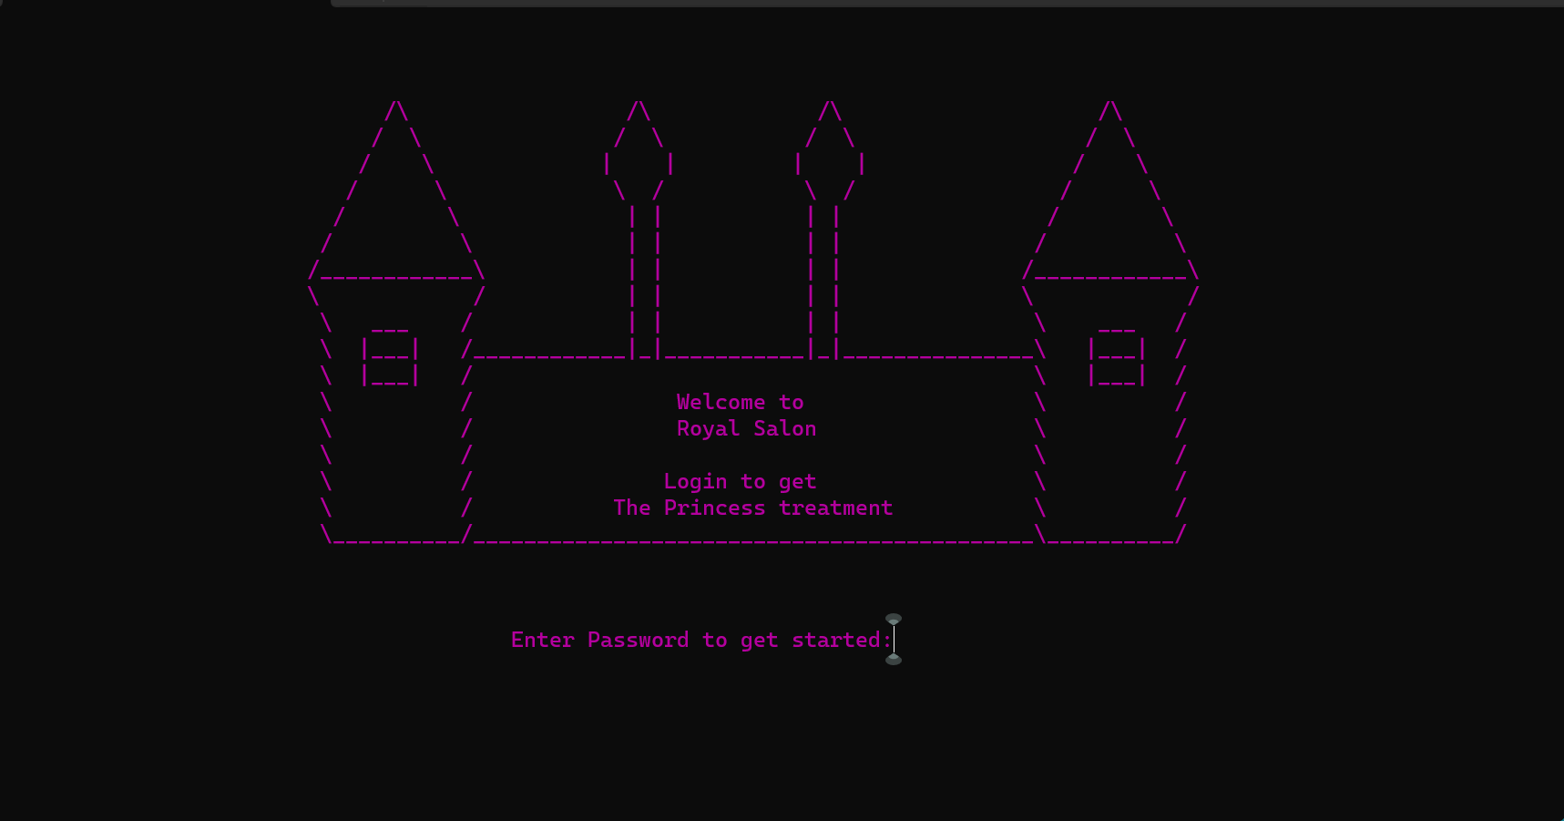

**Wrong Password:**

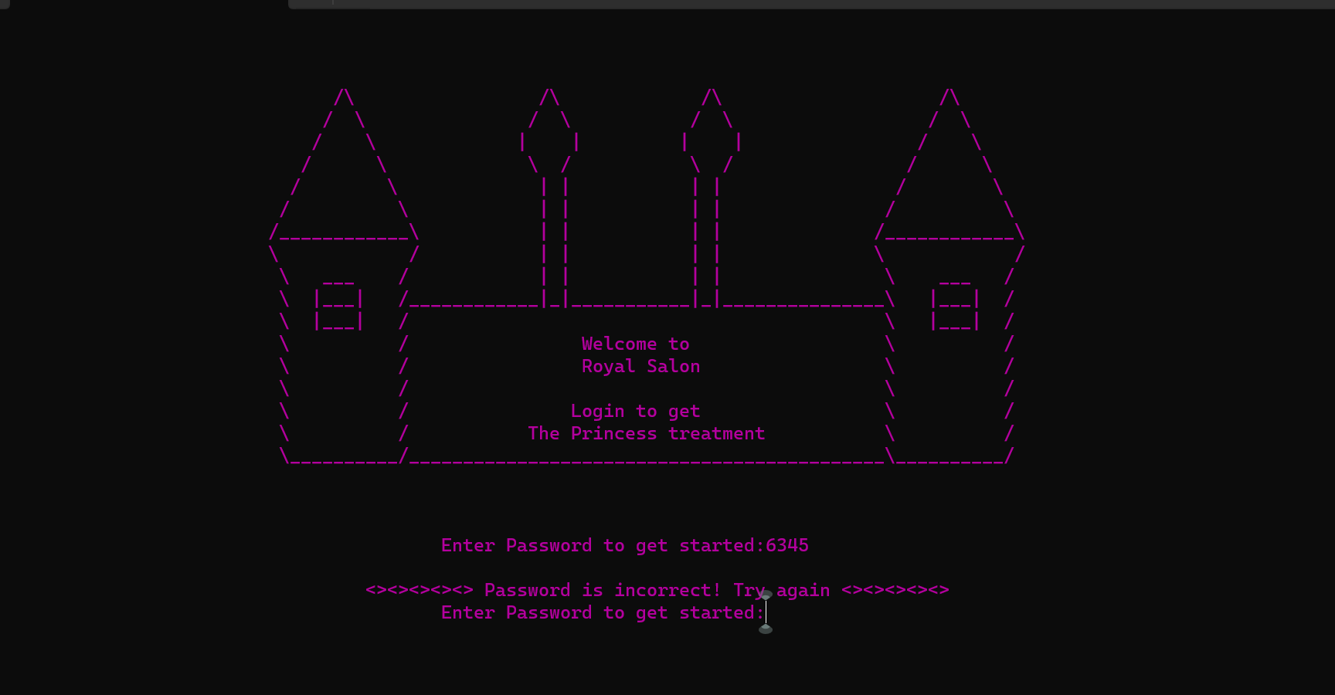

**Login Successful:**

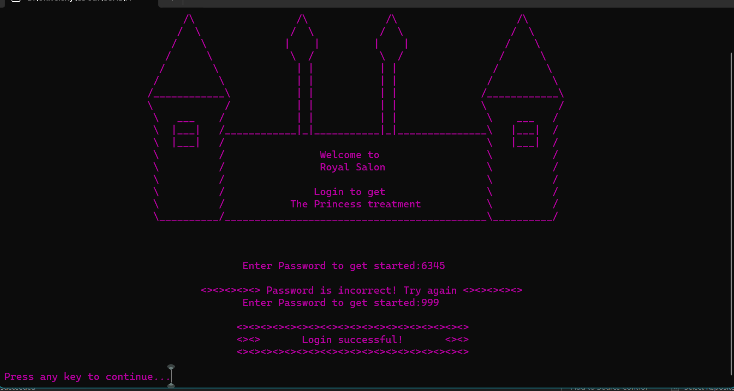

**Menu:**

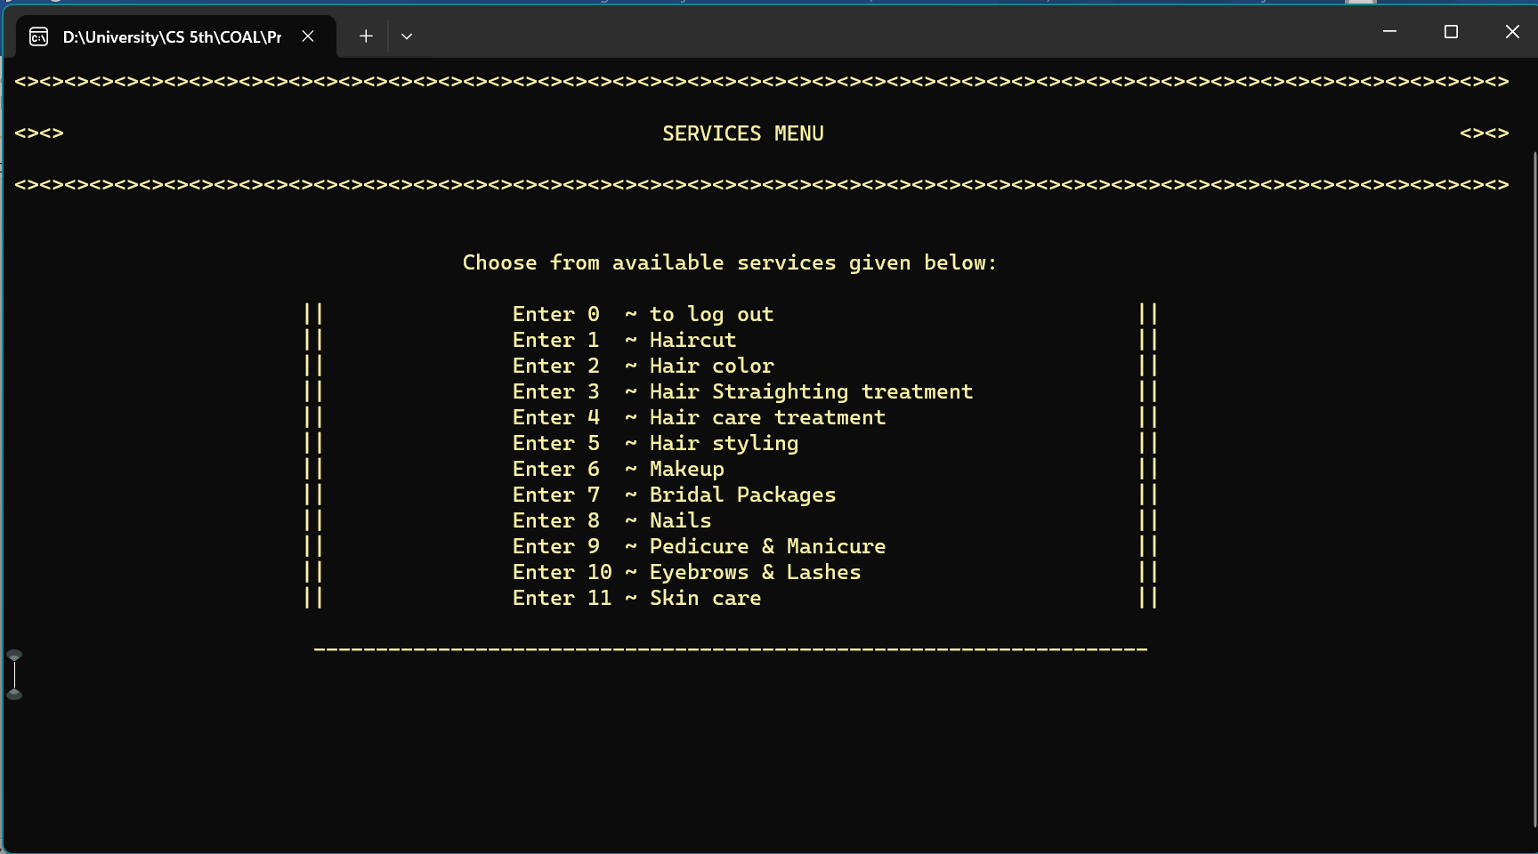

**Hair Treatment SubMenu:**

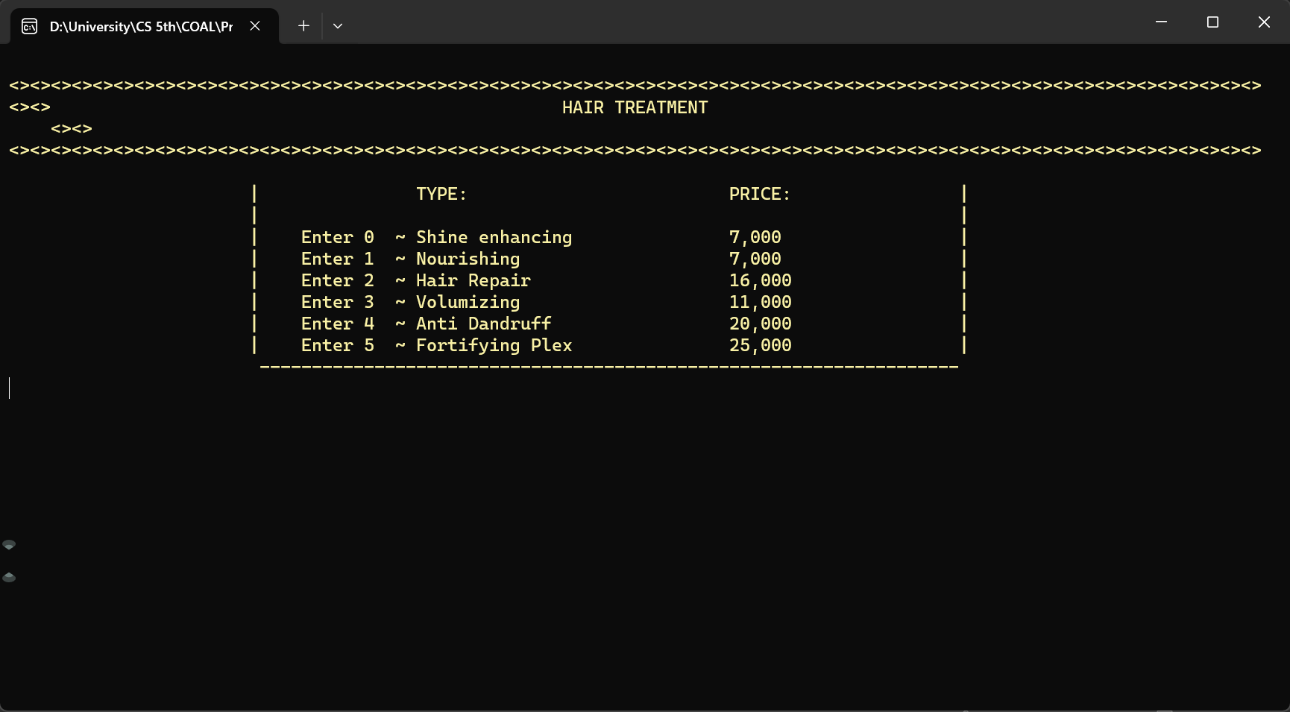

**Volumizing Selected:**

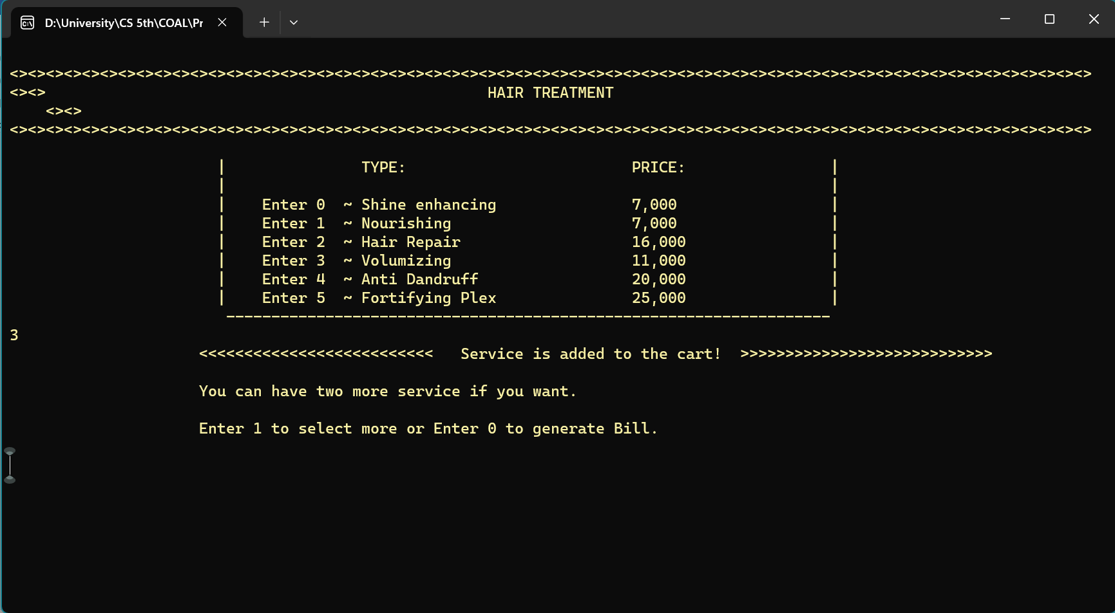

**Entered 1 to Select more Services:**

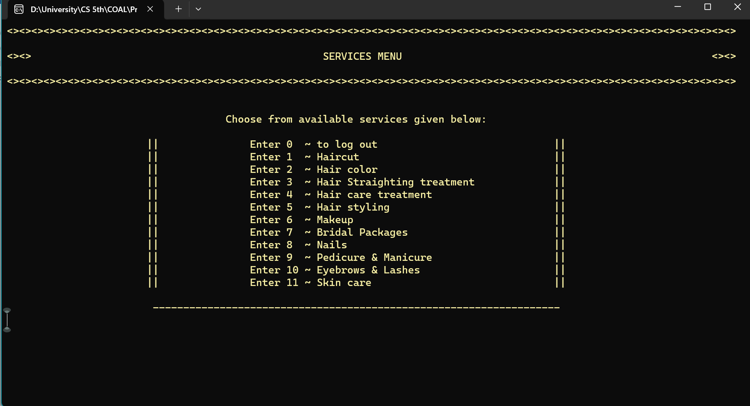

**Make Up Selected.**

**Make Up SubMenu:**

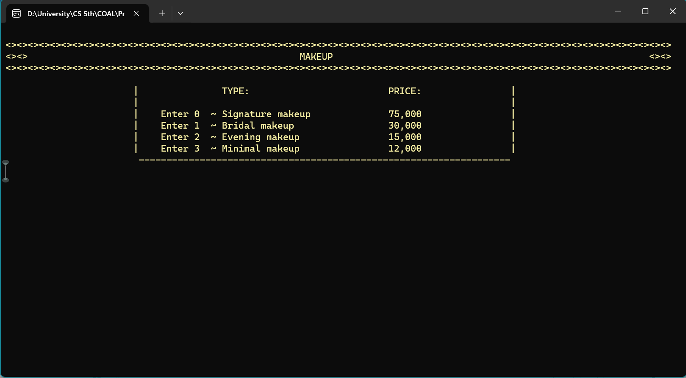

**Evening Make Up Selected:**

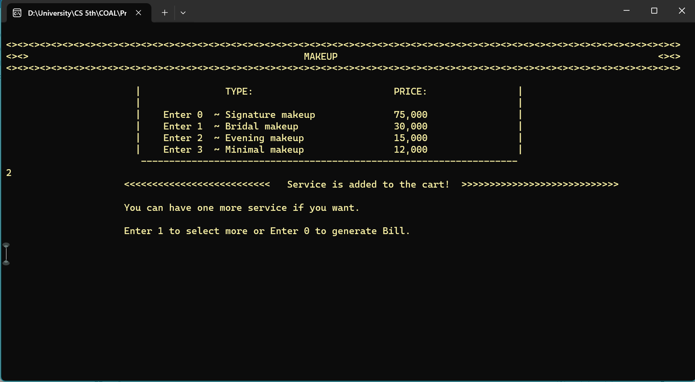

**Entered 1 to Select one more service:**

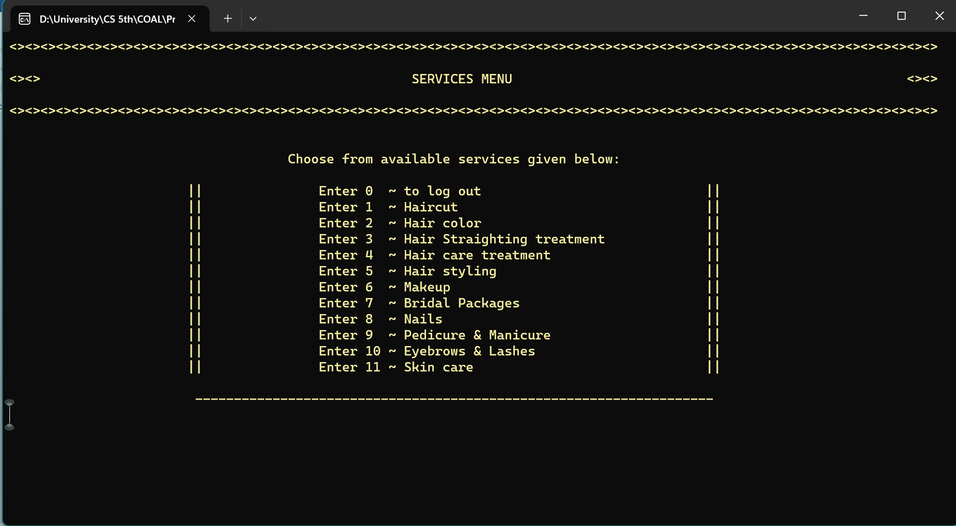

**Nails Selected.**

**Nails SubMenu:**

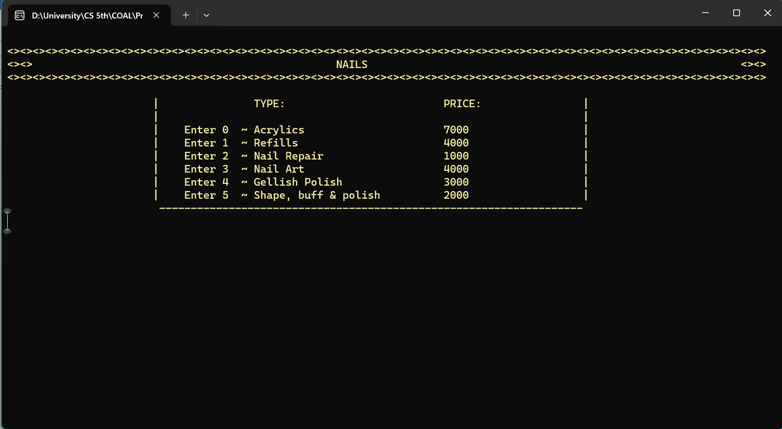

**Nail Art selected.**

**Bill generated:**

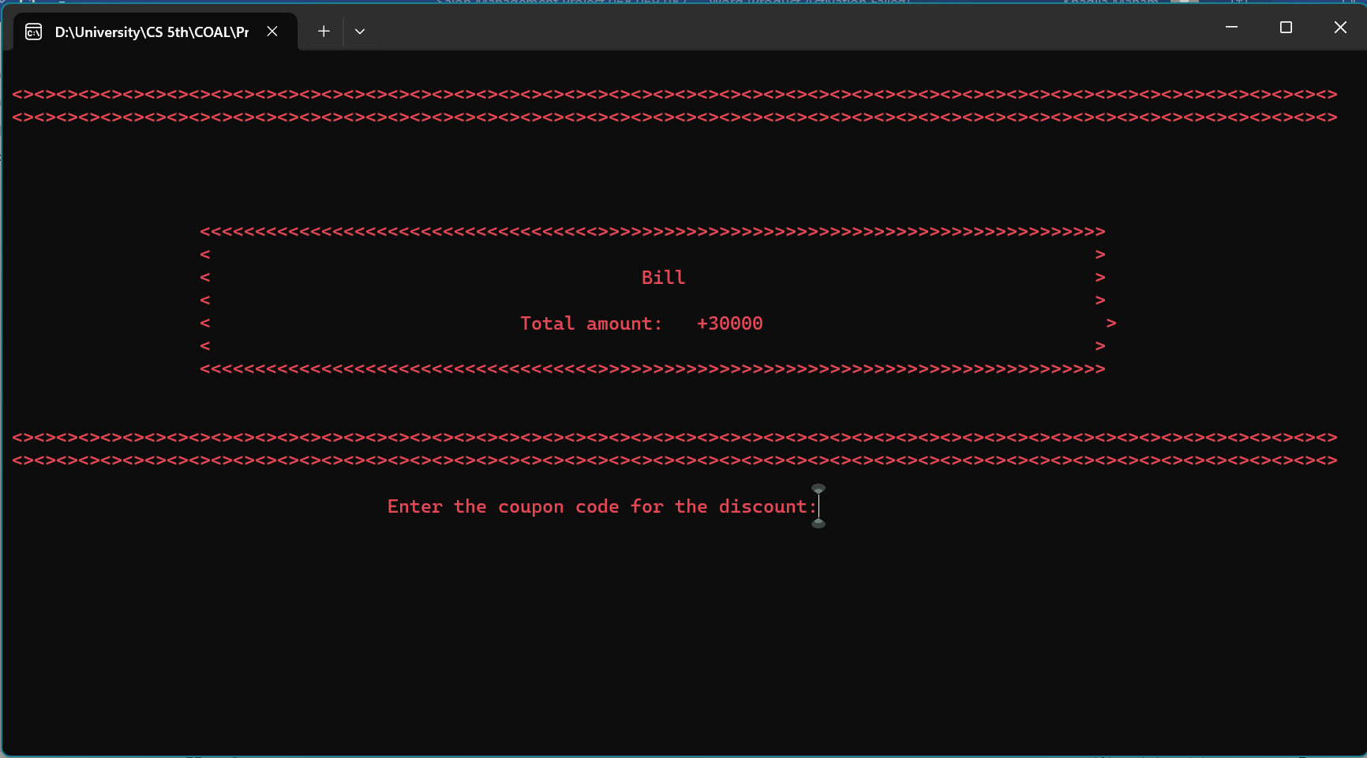

**Coupon code matched and discount given:**

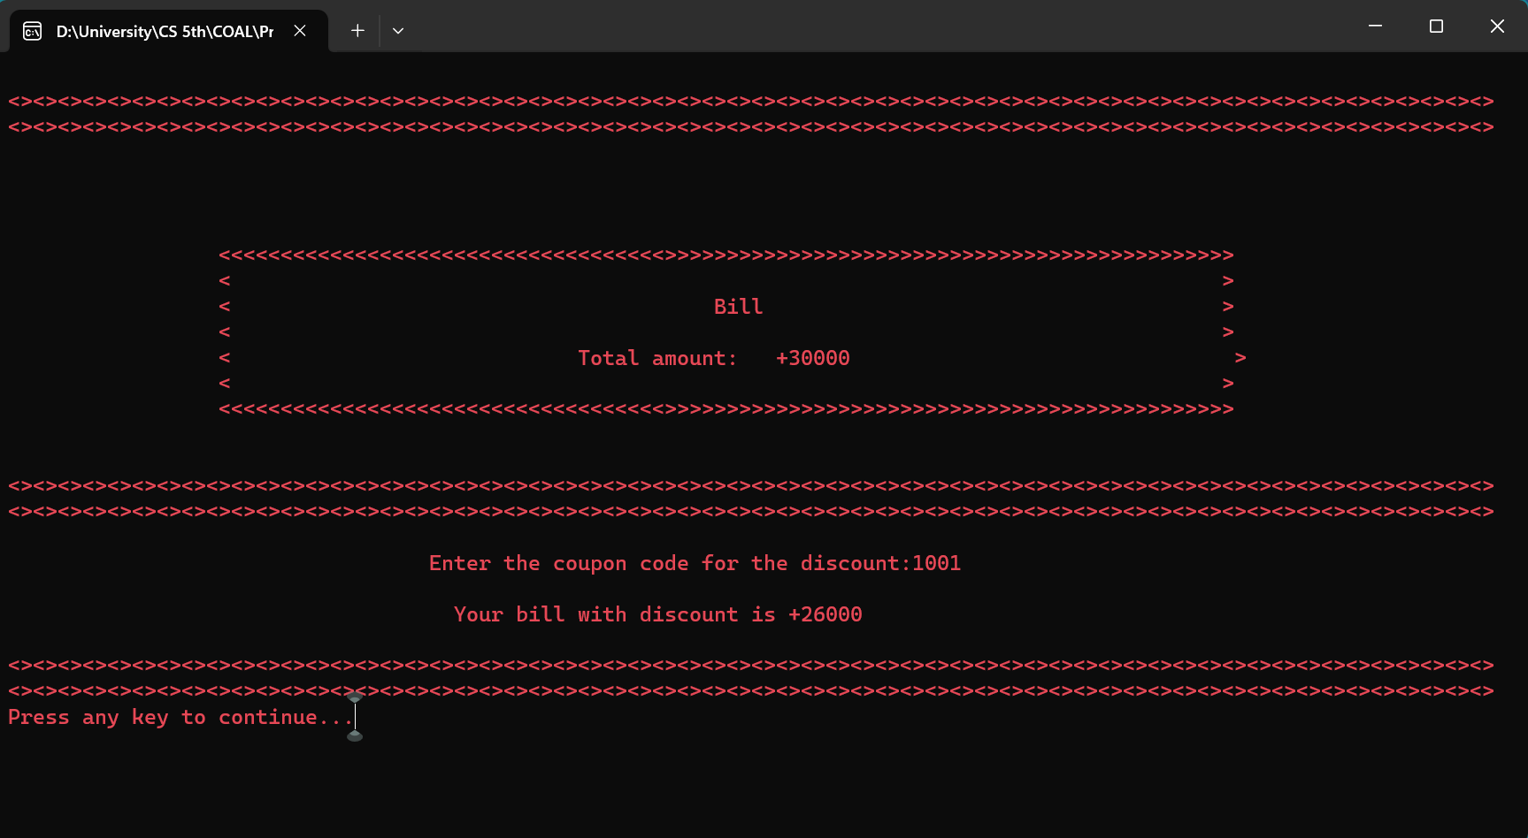

**Feedback asked:**

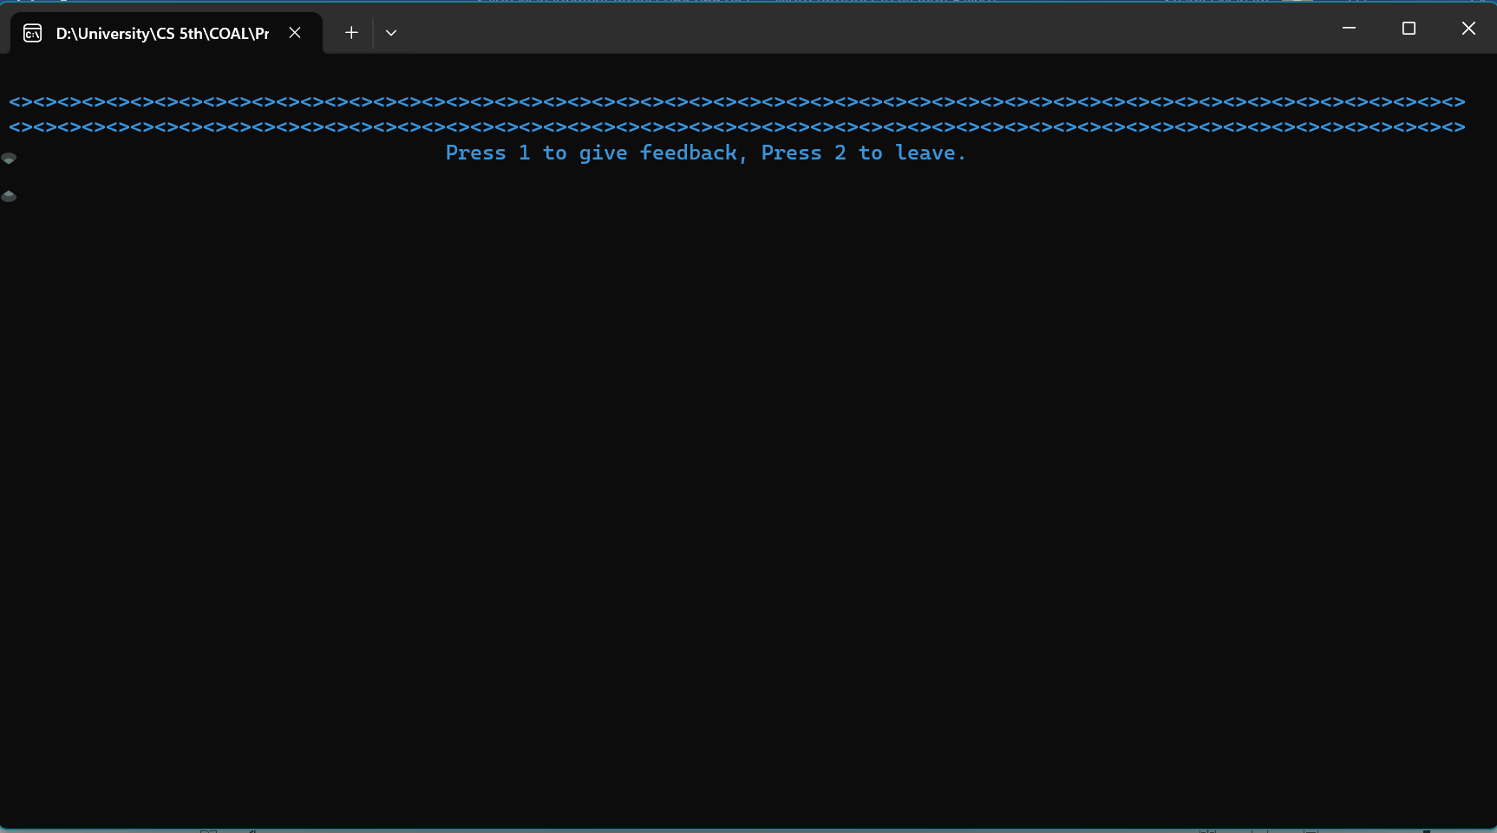

**Feedback given and thankyou message showed:**

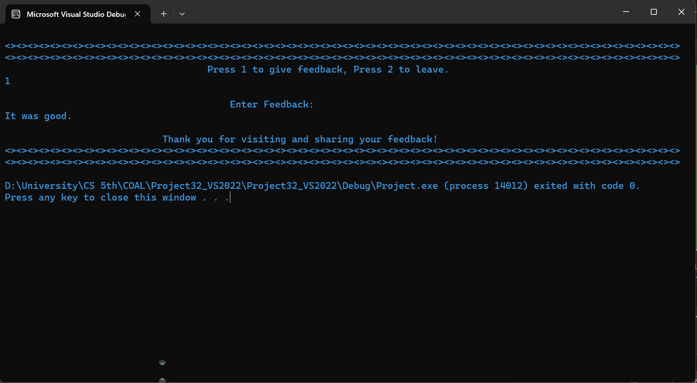

**End**